Address: Mobile No:8292179019,7643910871
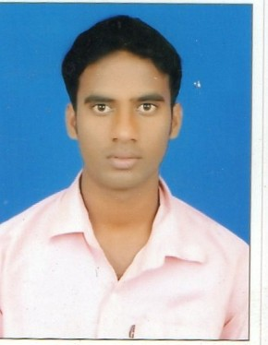
S/o-Md. Imamuddin
Vill+P.o-Matari,p.s-topchanchi
Dhanbad-828114
Email-mdjasim068@gmail.com

CURRICULAM-VITE
NAME-MD. JASIM

Objective
. To establish myself as a part of higher management in a professionally managed organization which offers growth opportunities & avenues to integrate own vision of success with total commitment to team work

Qualification:
Matric from JAC
Inter(I.sc) from JAC
Graguation(B.sc,MATH, HONS.) from VBU,Hazaribag
DCA&TALLY
TYPING(HINDI & ENGLISH)

Experience:-
ONE year Six month, working experience in computer operator
Persional Details:

Father Name:-Md Imamuddin
Date of Birth- 27th Sept. 1996
Language Known:- Hindi & English
Marital status:-Unmarried
Religion:- Muslim
Nationality:- Indian

Persional Strength:-
I am sincere and hard working who is quick lerner also. I adapt easily to my surrounding and mix well with people

Date:-
Place:- (Md Jasim)

