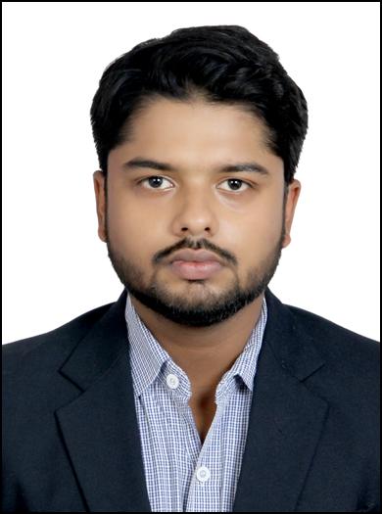
Deepak Dutt Pandey
Mob: +918860390007 E-mail Id: deepak.pandey4428@gmail.com
EDUCATIONAL QUALIFICATION

Class / Course | Year | School / College | Marks / Grades
PGDM / MBA | 2016 – 18 | IMM-FOSTIIMA Business School, New Delhi | CGPA – 5.67
B.Com | 2013 – 16 | Institute of Management Education , CCS University | 50.23%
Class XII | 2013 | S.G.Public School, CBSE | 58 %
Class X | 2011 | N.I.O.S | 62 %

SUMMER INTERNSHIP 8 Weeks (09/04/2017 to 09/06/2017)

As part of PGDM course at IFBS
- IDBI Federal Life Insurance Company Ltd
- Designation: Intern
- Key Responsibility Areas:
- Selling products of the company.
- Building customer relationship.

DISSERTATION PROJECT

As part of PGDM course at IFBS

Marketing strategies of Amul milk to compete with Mother Dairy milk.

- To Understand about the market of Amul milk
- To Understand the customer satisfaction and their expectation toward Amul milk
- To Understand steps taken by Amul milk to increase their customers
- To study the competition between Amul Milk and Mother Dairy
i.e. what steps Amul have taken to compete with Mother Dairy (specially in Delhi NCR)

ACHIEVEMENTS & AWARDS

- Won 1st position in Inter College Business Quiz competition (2014)
- Won 4 Gold medals in 400 mt Race in school , Long Jump, and Cricket (2006-2009) in school
- Won 1 Silver medal in 100mt Race in school (2007)
- Won 2 Bronze medal in inter-house football competition (2007)
- Became house captain in sports in school

EXTRA CURRICULAR ACTIVITIES & INTERESTS

- Like to play Cricket, Chess and Computer Games.
- Participating in athletics (100 mt race and 400 mt race ).
- Organising events.
- Gardening and cooking.
SKILLS

- Work efficiency
- Keen interest in organizing events thereby have acquired managerial skills
- Strong communication skills
- Good listening skills.
- Keen observer.
PERSONAL DETAILS

Date of Birth : 22nd October 1992
Father’s name : Mr. Shiwanand Pandey
Languages : English and Hindi
Marital status : Single
Present Address : B -202 Swarn Ganga Apt sector 06, Vasundhara Gzb

Date :

Place : New Delhi Signature

