Krati Sharma
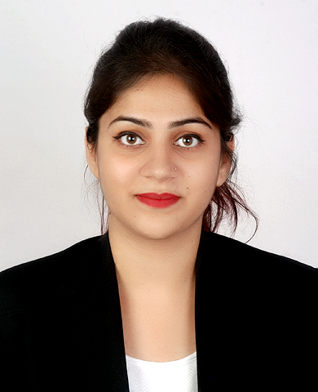
Vatskrati12@gmail.com

Contact No. 8377822921

CAREER OBJECTIVE
Seeking an opportunity to serve through my knowledge and efforts in order to learn and enhance my skills.

EDUCATIONAL QUALIFCATION
UNIVERSITY/SCHOOL | QUALIFICATION | CGPA/PERCENTAGE
Sharda University | Pursuing 5th B.Sc.LL.B | 7.4
Dehradun Public School | Higher Senior Secondary (Class XII); Affiliated to CBSE Board | 73.4%
Dehradun Public School | Senior Secondary (Class X); Affiliated to CBSE Board | 6.7

INTERNSHIPS
- PALAM AIRPORT LEGAL CELL (AIR INDIA) [ MAY 18, 2016- JUNE 2, 2016 ]
Worked as an intern at the legal cell
Internship Details- Work included attending tribunal proceeding, reading case files, making synopsis of cases and varied research work.
- VIPIN SAINI ASSOCIATION [ JUNE 26, 2016 – AUGUST 8, 2016 ]
Worked as an intern.
Internship Details- Work included Research, filing, attended court proceedings.
- NATIONAL CONSUMER DISPUTE REDRESSAL COMMISSION [ JULY 1, 2017 – JULY 31, 2017]
Worked as an Intern.
Internship Details- Work included court proceedings, research, reading case files, making report.
- UNDER ADVOCATE AMIT SHARMA [ JUNE 28, 2018 – AUGUST 8, 2018 ]
Worked as an Intern
Internship Details- Work Included court proceedings , Research and Drafting.

MOOT COURT EXPERIENCE

- Participated in JNU National Moot Court Competition, at Jagran Lake University Bhopal.
- Participated in AMITY National Moot Court Competition, Noida
- Participated in 5th Annual Intra Moot Court Competition, School of Law Sharda University
- Participated in 7th Annual Intra Moot Court Competition, School of Law Sharda University

SEMINARS AND OTHER WORKSHOPS

- International conference on “RULE OF LAW IN SUPPORTING THE 2030 AGENDA/SUSTAINABLE GOALS.
- Conference on “NATIONAL GREEN TRIBUNAL 2016”.
- MODEL UNITED NATION at IMS Ghaziabad.

OTHER ACCOMPLISHMENTS
- 2nd Position in Debate competition on ‘ Ban on surrogacy ‘ by Sharda University .
- 3rd Runner-up in Extempore, at Sharda University.

ORGANISATIONAL EXPERIENCE

- Member Moot Court Society (2015-2017).
Responsibilities include conducting and managing Moot Competitions, conducted by the University.

HOBBIES AND INTERESTS
I love travelling , exploring new places. Apart from internships, adventure sports and Painting occupy my time during vacations. I like to draw and paint regularly and in my free time I read books.

PRESONAL DETAILS
NAME- KRATI SHARMA

FATHERS NAME- MR. YOGESH SHARMA

DATE OF BIRTH- 12 JULY 1996

ADDRESS- E 14 DAYANAND NAGAR GHAZIABAD

NATIONALITY- INDIAN

LANGUAGE KNOWN-ENGLISH HINDI

I hereby declare that all above information mentioned above is true to the best of my knowledge.

Date;
Place: (KRATI)

