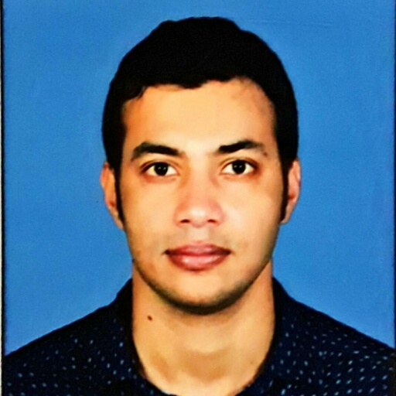

Sumit Kumar Majhi
Email: sumit96934@gmail.com
Phone: +91 9593840515 (M)

Looking for an opportunity to use the skill sets and knowledge I have acquired to foster the growth of the organization as well as enhance my knowledge.

Work experience

2) 19th Februaly 2018 to till date Working in Cogito Software Solutions Pvt. Ltd,Kolkata As Database Administrator/ DEveloper.

Roles:-
• Working on LevelImmo Real state.
• Working on Gofba Project Development(Search and Chat) and Email Server.
• Working on Recruiter management system.
• Working on GTFS Project Development(Development and Deployment).
• Database Mirroring Configuration and Monitoring.
• Always On Availability Configuration and Monitoring.
• Production Database Live and Network Backup on Clients End.
• User Creation,Installation,Restore.
• Query And Procedure Writings(SQL & TSQL).
• Troubleshooting Various Database Related Issues and DatabaseTesting.

1) 1st May 2015 to 17th 2018 Worked Wizard e marketing pvt ltd. As Database Administrator.

Roles :-
- Database Backup, Restore, Refresh, Creation.
- Extensive experience in writing stored procedures , functions and views.
- Extensive experience in writing and tuning complex sub query, SQL, stored procedures, functions and triggers.
- Resolving Log space issues
- Troubleshoots companys and subsidiaries’ database issues and applications
- Verify and Qualify SQL Servers prior Installation
- Analyzed, conducted and implemented physical database designs
- Monitored database performance, tracked and stored procedures and queries’ execution times and implemented improvements on efficiency
- Oriented other database administrators on SQL Server management including upgrades and migration
- Configure Log Shipping.
- Develops, tests and institutes SQL scripts
- Experience with Import/Export, Backup/Restore
- Generated reports from the database using SQL.

Computer Skills
Programming Languages : C, C++, C#, Java, VB
Database : ORACLE, SQL Server 2005 Or SQL Server 2008,SQL Server 2012, SQL Server2016
Operating System : Windows 2000 / 2003 / XP, Windows 7,Ubuntu

Web Technologies : HTML, CSS, JavaScript, Jquery

Concepts : Oops
Education
- Meghnad Saha institute of Technology, Kolkata
- Master of Computer Application (2015).
- Ranchi University, Ranchi
- B.Sc. Mathematics ( 2012)

Academic Certificate
- Certified Course In Complete Dot Net With Project From CMC Academy (A Tata Enterprise)
- Completed Training & Project On App Development Using “.Net Framework” Under “knowledgelab”

Academic Project

- “Online Banking System” By ASP.NET, Database- Oracle 10g Certified CMC Academy.
- “Course Finder’” By ASP.NET, HTML ,Database- SQL Server 2008 During MCA Industrial Training Under “knowledgelab” Of “Meghnad Saha Institute Of Technology”.
- “Human Resource Management” Developed By ASP.NET, Database- SQL Server 2008, During MCA
Minor Project.
- “Astrology” By JSP, Class, SERVLET,HTML,CSS, Javascript, Database-
SQL Server 2008, During MCA Major Project.

Personal Profile

Name : Sumit Kumar Majhi

Father’s Name : Mihir chandra Majhi

Mother’s Name : Tripti Majhi

Nationality : Indian

Gender : Male

Adderess : Vill.-Sdhi,P.O.-Sidhi,P.S.-Joypur,Distict- Purulia,Pin- 723213,West Bengal,India

Date of Birth : 07/02/1991.

Co-Curricular activities : Internet Surfing , Sports(cricket) , Listen music

Marital Status : Single

Language Known : Bengali , Hindi , English

I hereby declare that the above information is true to the best of my knowledge and belief.

Date: --------------------------------
Place: Kolkata (WB) Self Signature

