RESUME
Name -: SUHEZ KHAN
Mobile -: +91-7532864181, 9917606027
Email -: suhezkhan143@gmail.com
Passport No. -: L9151397

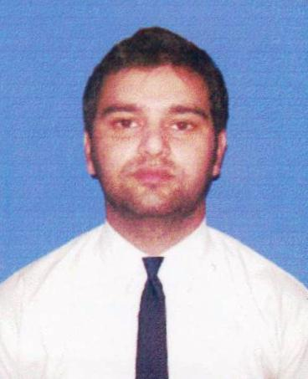

QUALIFIED IT PROFESSIONAL

- To demonstrate my potential in the field of "Information Technology", and utilize my skills for self and company growth

PROFILE SUMMARY
- Well versed with:
- Open Sources : Prestashop, Wordpress , Joomla.
- Skill Sets : php, mysql, Jquery, HTML5, CSS3, Bootstrap, Angular JS, plugins integration and Javascript.
- IDE : Dreamweaver, Netbeans 8.0 , Notepad++.
- Database Designing.
- Graphics / Multimedia : Photoshop, Pixlr.
- Php frameworks : Codeigniter, Working Knowledge of Yii.
- Work on Search Engine Optimization.
- Onsite page optimization through Google tools and GTMetrix.
- Testing / Debugging web application tools.
- Managed Benchmark account for the company and to create Newsletter/Banner.
- Designing UI while achieving Customer/user Friendliness.

ORGANIZATIONAL EXPERIENCE

Dec’ 17 to Currently Working : The Indian Movie Channel (TIMC)

Key Result Areas:

- Projects Undertaken : theindianmoviechannel.com
Roles : Frontend and backend Developer
  - Environment: - PHP, Codeigniter, HTML5 , Bootstrap and jquery.
  - Optimization through GTMetrix tools.
  - Use of photoshop to create images and use of html, css and javascript for front end design layout.

Aug’ 16 – Dec’ 17 : Zmart Tech Partners Pvt. Ltd.

Key Result Areas:
- Projects Undertaken : www.baromeeter.in
Roles : Frontend and backend Developer
  - Environment: - PHP, Codeigniter, HTML5 , Bootstrap and jquery.
  - Testing / Debugging web application tools.
  - Optimization through GTMetrix tools.
  - Use of Framework7 to make mobile compatible.
  - Use of photoshop to create images and use of html, css and javascript for front end design layout.

- Projects Undertaken :
www.planittravglobal.com
Team Strength : 6
Roles : Team Member

Responsibilites :
- Designing
- Customization
- coding
- Module Creation
- Data Validation
- Bug Tracking

- Projects Undertaken :
Eprefect.in
Team Strength : 5
Roles : Team Member

Responsibilits :
- Coding
- Work on yii framework
- Design interface
- Created inter office web tools in yii.

Sep’ 14 – Jul’ 15 : Punjab Web Hosting

Key Result Areas:

- Work on Joomla CMS.
- Editing images and updating the content.
- Reduced inconsistencies and usability issues.
- Testing / Debugging web application tools.
- Projects Undertaken :
- www.optfresh.com
- http://baanka.com/
- http://aischool.in/
- http://famesky.com/
- http://careitservice.com/
- http://editworks.co.in/
- http://finalcut.co.in
- www.eclubnoida.com
- www.ibc.org.in

Jul’ 13 – Aug’ 14 : Trigr

Key Result Areas:

- Designing
- Work on Joomla CMS.
- Editing images and updating the content.
- Customization
- Optimizing web assets for optimal speed and performance.

ACADEMIC QUALIFICATIONS

2013 B.Tech. (Computer Science & Engineering) from Uttar Pradesh Technical University
2009 XII from J.P. Academy, Meerut (CBSE Board)
2007 X from Noble Public School, Meerut (CBSE Board)

PERSONAL DETAILS

Date of Birth: 31 Oct 1993
Personality Traits: Goal Oriented, Hard Working, Punctual,Good Interpersonal & Communication Skills.
Address: Katwaria Sarai, Hauz Khas, New Delhi, India.
Languages Known: English, German, Hindi and Urdu
Location Preference: Delhi NCR
Nationality: Indian
Marital status: Single

