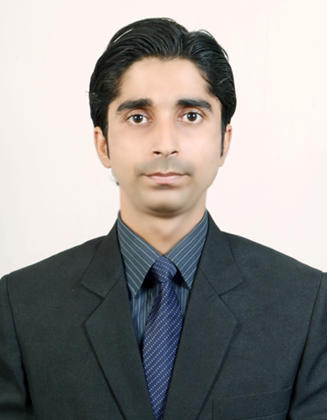
Aishwarya Tiwari
Graduate Developer
Address : Street No 7, OM Nagar, Gurgaon
aish.vns@gmail.com
mobile : +91-7840840639

Career Objective:
I intend to establish myself as a Technology professional for the company's growth by using my technical, functional and communication skills.

Professional Summary:
- Software professional with 2.0 years of experience of Software development in various Microsoft technologies like C#, ASP.NET, MVC.
- Working on all the phases of the project Software Development Life Cycle (SDLC) such as Requirement Analysis, Design, Construction, Testing, Implementation
- Study the requirements of the clients and the specific needs of the business projects.
- Build And Customize the developed applications as per the client specifications
- Provide assistance in team activities by handling secondary responsibilities.
Skills:
Languages: C, C#.NET, HTML & CSS, ASP.NET with AJAX,MVC.
Tools : Microsoft Visual Studio 2010/2013.
Database : Microsoft Access, SQL Server 2005/2008/2012.
OS : Windows 9X/2008/XP/vista/7/10.

Professional Experience:

BSL Information Technology Private Limited (NOV 2016 – OCT 2018)

- Working at as a Graduate Developer for BSL Information Technology Private Limited over 2.0 year of experience.
- This experience has enriched my knowledge in designing, developing and testing applications with. NET framework while giving me an opportunity of working on projects of diverse domains such as finance, educational institutes, etc.
Academic Qualifications:
- Master of Computer Application from GBTU with 75.85% in 2013.
- Bachelor of Computer Application from MCNUJC with 73.90% in 2010.
- Intermediate: UP Board with70.00% in PCM in 2007.
- High School: UP Board with 59.00% in 2004.

Projects Developed and Tested:

- WCM - A Web application for managing Manufacturing related Record.
Skills used:
· C#.NET
· SQL Server 2012
· MVC2,Jquery.

Role: Coding and Testing.
Debug, test and create Test cases according to requirement.

- IDHAMMER- This was reporting based project which generates different reports for different purpose based on query input.
Skills used:
· C#.NET
· SQL Server 2012
· MVC5,Jquery.

Role: Coding and Testing.
Debug, test and create Test cases according to requirement.

- Itrack - A Web based application which used for maintaining the timesheet of working hours which spent by employee on different projects or different module .
Skills used:
· Asp.net, C#.NET
· SQL Server 2012

Role: Coding and Testing.
Debug, test and create Test cases according to requirement.

Personal Profile:
Gender: Male
Date of Birth:18-07-1991
Marital Status: Single
Hobbies: Article Reading, make friends.
Language Known: Hindi and English.
Permanent Address : Shastri Nagar Sigra ,Varanasi.

Nationality: Indian
Declaration:
I hereby declare that the above mentioned information is correct up to my knowledge and I bear the responsibility for the correctness of the above mentioned particulars.

