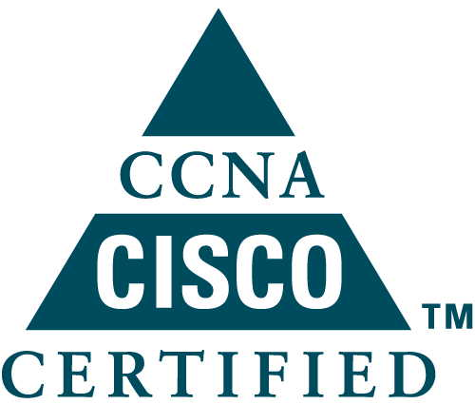
VEERU VISHWAKARMA

Contact: +91-9200739599,8962339939
E-mail: (veeruvishw@gmail.com)

Seeking a challenging position in an organization and enthusiastic about telecom specially computers and communication network .
PROFESSIONAL SYNOPSIS

IT Professional with 3+years’ experience in , Service Operations & Maintenance in IT & Telecom Industry. Expertise in planning, engineering, managing and executing Telecom projects including installation, operation and maintenance of Telecom Systems. Possess fundamental knowledge on Wireless Communications, Operations and Maintenance of large Telecom Network.

ORGANISATIONAL EXPERIENCE
CAREERS EXPERIENCE:-21 June’13 – Till Now

Working in Vihaan Network Ltd.(Shyam Telecom) Gurgaon from October 2015 to Till Now.

Designation: Network Engineer

- Troubleshoot of Firewall, IPS, QOS and VPN technologies.
- Working on cyberoam sophos UTM.
- Working on Network Security Ethics .
- Working on L3,L2 Switches (Cisco,Dlink,HP,Juniper).
- Software up gradation of Network elements.
- STP / RSTP/ MSTP with Inter-VLAN Routing. Root causes Analysis.
- Hands on and experience on Cisco & Motorola wireless devices (Controller and access point).
- Commissioning and Network configuration for all TX Nodes
- 2G & 3G Rings. Migration of sites from BST to BSC & 2G to 3G & FNP to FNP.
- BTS,BSC,RMC,EDS- IP Based Devices configuration and troubleshooting.
- Abis Media Configuration for BSNL (VNL) BSC.
- GB-(SGSN) Configuration on BSC and Firewall.
- VSAT Link Creation for Abis .

Worked in Smriti Netcom Pvt. Ltd. Bhopal from June 2013 to 30 September 2015.

Designation: Network Administrator

- Configuring and maintaining Cisco Routers 1700, 2500, 2600 & Cisco Switches 1900, 2950
- Network routing protocols using Dynamic (RIP/ EIGRP / OSPF ) & Static Routing.
- Troubleshoot Operating System, network connectivity, and end-user problems. Provide technical support and user training.
- Install, upgrade, support and troubleshoot Windows 7, XP, Printers, Computer hardware and other peripheral equipment.
- Responsible for handling all Lotus Notes Clients activities such as configuration, id installation, Achieve settings & Troubleshooting. Knowledge of outlook configuration, installation and troubleshooting.
- Configuring and troubleshooting VLANs, STP, VTP, Trunking, HSRP, and VRRP.
- Migration process on Cisco router.
- Working as a Transmission Engineer for Vodafone GSM Project.
- .

Job Description:

- Responsibilities to take backup on require & schedule basis.
- Monitor network performance and troubleshoot problem areas as needed as well as test network performance and provide network performance reports.
- Create and maintain documentation as it relates to network configuration, network mapping, processes, and service records.
- Practice network asset management, including maintenance of network component inventory and related documentation and technical specifications information.
- Provide operational support as required to update network configurations or resolve network issues.
- Monitor network performance and troubleshoot problem areas as needed as well as test network performance and provide network performance reports.
- Configuration, installation & Maintains of Cisco Routers.
- Installation, maintenance, configuration of Optical Modem.
- Managing electric devices, power resources, battery bank.
- 100% network availability by managing well planned preventive maintenance.

QUALIFICATIONS
S.No. | qualification | Subject | University | % age | Year
1 | B.E. | Computer Science | R.G.T.U | 72 | 2009-13
2 | 12th | Science | M.P.BOARD | 53 | 2009
3 | 10th | Science | M.P.BOARD | 65 | 2007
4 | MCP-410 | MCSA | Micro-soft | 92 | 2014
5 | CCNA | Routing & Switching | Cisco | 95.8 | 2015

IT SKILLS
- Operating System WINDOWS Client OS , WINDOW SERVER 2012, Linux
- Languages C, C++
- Packages MS OFFICE 13
- Data base SQL SERVER 2007
Youtube Channel :-

- https://www.youtube.com/user/veeruvishw007
Blog :-

- http://techforensics.blogspot.in
PERSONAL DETAILS
- Date of Birth 06/02/1992
- Present Address H-4/50 Police Colony Jbad. Bhopal
- Sex Male
- Marital Status Unmarried
- Nationality Indian

DECLARATION

I hear by declare that all statements made in this application from are true and correct to the best of my knowledge.

Date:
Place: Gurgaon Veeru Vishwakarma

