CURRICULAM VITAE

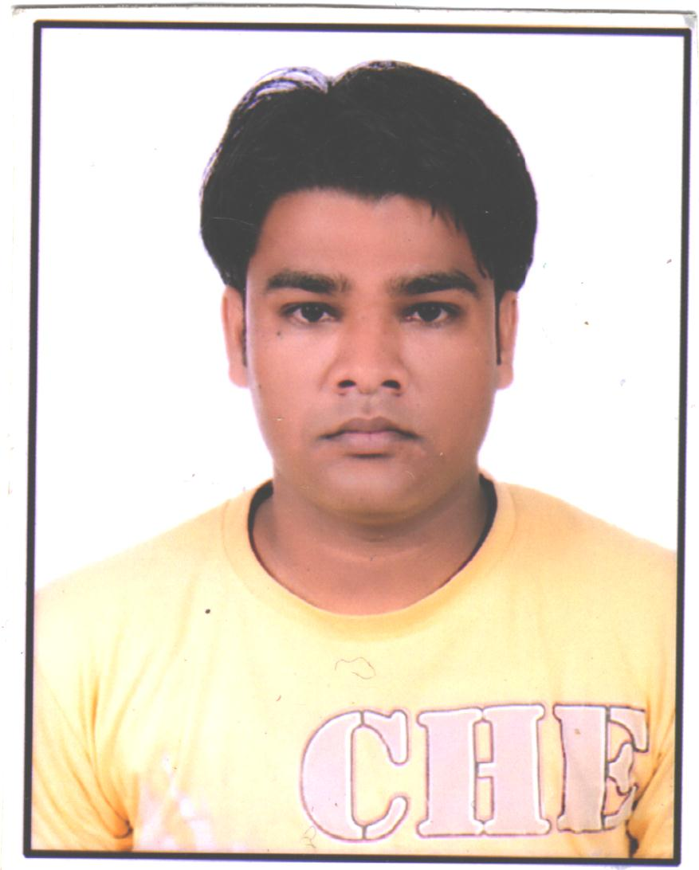

JONY KUMAR
S/O Sh. Vinod Kumar
Vill+Post-Baheri
Distt; Muzaffarnagar (UP)
Pincode-251202.

Correspondence address:-
Jony Kumar C/O Mr. Jaiveer
145 Kamna type Sector 5
Vaishali, Ghaziabad
Ghaziabad 201010.
Mobile : +8800208623
Email:- kumarjony7@gmail.com

Career Objective:-

To work on a challenging job profile which provides an opportunity to enhance my knowledge, this could provide me an insight into new aspects so that it would be helpful for my career.

Education:-
Degree | Year | College | University/Board
B.A | 2011 | D.A.V Muzaffarnagar (Uttar Pardesh) | Chaudhary Charan Singh University.
Intermediate | 2008 | A.I.C. Muzaffarnagar (Uttar Pardesh) | UP Board Allahabad.
High School | 2004 | A.I.C. Muzaffarnagar (Uttar Pardesh) | UP Board Allahabad.

Professional Qualification:-
Degree | Year | College/Institution
Computer Hardware & Networking Diploma. | 2011 | Jetking Muzaffarnagar (Uttar Pardesh)
4 week Diploma in Data Entry Operator. | 2012 | Doeace Society Inderlok New Delhi.

Experience Summary:-

3 Years experience as a Contact basis Data Entry Operator in East Delhi Municipal Corporation.
Name of the Company | Role | Duration
Doeacc Society Inderlok New Delhi. | Data Entry Operator Hindi, English Typing work. | Dec 2012 to 2014 Jan
Intelligent Communication Systems India Ltd Okhla Ph-III. | Data Entry Operator Hindi, English Typing work. | Jan 2014 to 2015 Nov

Currently Working:- Litchi Knowledge Centre Pvt.Ltd Vasundhra Ghaziabad as a MIS TRAINEE

Key Skills:-

MS Word, Excel, PowerPoint.

Internet.

Typing speed – 45wpm in English.

Typing speed – 30 wpm in Hindi.

Personal details:-
Date of Birth : 27th June 1989
Nationality : Indian
Gender : Male
Father’s Name : Sh. Vinod Kumar
Languages known : Hindi,English
Marital Status : Unmarried

Declaration:-

I hereby declare that the above information is true to the best of my knowledge and belief.

Place: GHAZIABAD
Date: (JONY KUMAR)

