Vikar Ahmed Lone 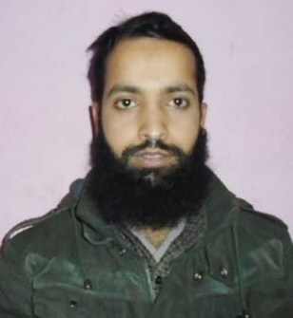

Email ID: vikarlone0786@gmail.com
vikarlone786@rediffmail.com

Contact No.: +919419155253, +919858293915

Career statement: To obtain challenging & responsible position in an organization where I can contribute to the successful growth of skill to further improve my personal & professional skills.

Synopsis

- Proficient with MS Office and Internet.
- Efficiently got experiences during the curriculum.

Academic Qualification

- XII from JKBOSE.
- X from JKBOSE.

Technical Qualification

- MCA from Punjab Technical University Jallandhar.
- BSC IT from Punjab Technical University Jallandhar. .

ITS Skills

Hardware
- Operating System - Installation of MS DOS, Windows 98, Windows2000 Professional, Windows XP, Windows Vista, Windows 7, Windows Server 2003, Windows server 2008, Linux.
- Application – MS-Office 2000,2003 & 2007 (Word, Excel, PowerPoint)

Strengths

- Believe in team spirit.
- Self confident & Positive attitude.

Hobbies

- Listening music.
- Reading books.
- Playing games.

Personal Dossier

- Father’s name : Late Bashir Ahmed lone
- Date of Birth : 15-07-1985
- Sex : Male
- Marital Status : Single
- Nationality : Indian
- Language Known : Hindi , English, Urdu & kashmri
- Permanent address : Bhadarwah Jammu and Kashmir

Date:

Place:
(Vikar Ahmed Lone)

