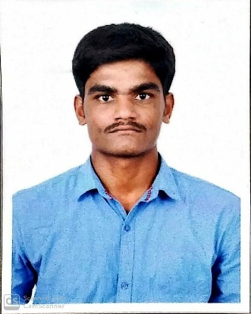
G.KARTHICK
ganeshkarthick00014@gmail.com
+91-9787198426

CAREER OBJECTIVE

To utilize my skills in a way for achieving company’s goals and to enhance my professional skills in dynamic and stable workplace.
WORK EXPERIENCE
Company Name - Team computers private Ltd
Designation - Desktop Support Engineer (L1)
Duration. - July 2019 - Till now
ROLE
- Software update and Installation
- Troubleshooting
- OS Installation
- Outlook Configuration
- LAN Setup
- Printer configuration
- IP configuration
- Printer installation.
- AD user creation and deletion
- Lotus notes configuration
- Network port checking and configuration
- Ticketing tool

EDUCATIONAL QUALIFICATION
- Master of Computer Application at Srinivasan College of Arts & Science, Perambalur with 75% in 2019.
- Bachelor of Computer Application at Srinivasan College of Arts & Science, Perambalur with 75% in 2017.
- HSC at Moulana higher secondary school, Perambalur with 72% (March 2014).
- SSLC atGovt higher secondary school , Kurumbalur with 68%(March 2012).

AREA OF INTEREST
- Hardware
- Networking

PROJECTS DISPLAYED
- “GK-Tail+ An Efficient Approach To Learn Software Models” at Srinivasan College of Arts & science,Perambalur.
MEMBERSHIPS
- Rotract club, Srinivasan College of Arts & Science.
AWARDS AND HONOURS
- STUDENT EXCHANGE PROGRAMME AWARD by Department of Management Studies (DoMS) at Srinivasan College of Arts & Science, Perambalur.
HOBBIES
- Net surfing
- Singing
EXTRA-CURRICULAR ACTIVITIES
- Played in District level cricket match at Perambalur in 2018.
PERSONAL PARTICULARS

Father’s name :Mr.R.Ganesan
Mother’s name :Mrs.G.Muthammal
Date of Birth :May 02,1997
Languages known :Tamil,English
Address :272/5, South Street, Thiruppeyer (Po)
Peramabalur (Tk& Dt), Tamilnadu.
Pin code : 621107.

DECLARATION
I hereby declare that the above cited information is true to the best of my knowledge and belief, if given a chance, I can prove myself.

