Curriculum Vitae
Mukesh kumar jha  Rz-7a raghu nagar  Main pankha road  New delhi-45  MOB:-08882083036,7645848889  E-mail:-mukeshkumarjh421@gmail.com | 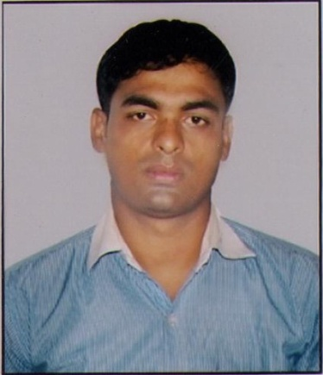
CAREER OBJECTIVE

“I would like to work in challenging environment where I can show my abilities, talent and sense of dedication towards my duties with a sole aim of seeing he progress of my company and myself”.

EDUCATIONAL QUALIFICATION
- 10th Passed from Bihar Board in year 1999 second division.
- Intermediate passed from Bihar Intermediate council in year 2002 second division.
- B .com (H) from L.N.M University Darbhanga in year 2005 First Class.
PROFESSIONAL QUALIFICATION
- MBA (Marketing or Hr) from SMU in year 2009-10.
COMPUTER KNOWLEDGE
1) Basic knowledge.
2) M.S OFFICE 2007
WORK EXPERIENCE
1) Worked at HAIER INDIA Pvt. Ltd. From oct.2015 to oct. 2016
2) Worked at NANSON OVERSEASE From sep.2014 to april 2015.
3) Worked at PANASONIC INDIA PVT LTD (JSO Western Up ) From Aug 2010 to 2014.
4) Worked at LG , from Sep 2008 to April 2009.
5) M/s RELIECNE COMMUNICATION in Jan 2008 to Aug 2008.

TRAITS
- Confident and enthusiasm
- Creativity and problem solving skill
- Quick learner and strong willing power
HOBBIES
- Watching movie, internet surfing
GAME
- Good player of cricket (selected and played for BIHAR INTERMIDIATE & UNIVERSITY TEAM DARBHANGA)
LANGUAGE KNOWN
- Hindi
- English
PERSONAL DETAIL
Father’s name : Sh.Bashisht Narayan Jha
Mother’s name : Shri mati Ginni Devi
Date of Birth : 22nd July 1983
Height : 6’1”
Nationality : Indian
Marital Status : Married

PERMANENT ADDRESS
Vill-Murliya chak
Tola-Bajraha
Post-Ganaur
Dis-Madhubani (Bihar)

DECLARATION
I hereby affirm that the information in this document is accurate and true to the best of my knowledge.
Date. (MUKESH KUMAR JHA)

