PAWAN KUMAR
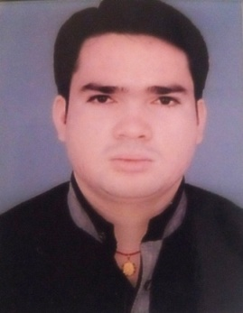

Residential Address
House No-- E-32
New Seelampur
Dehli-110053
Mobile: - +91-9266845805, 9999642312
E-mail:- Mahorrr556@gmail.com

OBJECTIVE:-

- To work in challenging environment where I can utilize and enhance my skills and make a positive contribution to the organization.

- Intend to build a carrier with a reputed leading corporate of hi-tech environment with committed and dedicated people, which will help me to explore myself and realize my potential. Willing to work as a key player in challenging and creative environment.

Attribute / Strength

- Positive Attitude & Willingness to Learn.

- Quick learner with ability to grasp new things.

- Initiative Strong Nature & Hard Working.

- Ability to work in both independent and team environment.

Academic Qualifications

- 10th from CBSE Board in Year 2007

- 12th from CBSE Board in Year 2010

- Six Month Certificate of Tourist Guide in ITI Shahdara, Delhi

- Pursuing B.A (Graduation) from University of Delhi.

Computer Skills

- Applications: Microsoft Office

- MS- Word • MS- Excel
- MS- Power point • MS- Access

Work Experience
.

- 1 Years Experience Aadhar Card (UID) Computer operator at Tera Soft Ltd. & Data Soft Ltd

- 3 Years Experience Store Incharge in Abhipra Capital Pvt. Ltd

- 1 Year Experience in Data Soft Computer Service Pvt Ltd as Scanning and Data Entry Operator in Delhi High Court Branch.

PERSONAL DETAILS

Name Pawan Kumar
Father’s Name Mr. Moti Lal
Date of Birth 13th AUGUST 1991
Gender Male
Nationality Indian
Mother Tongue Hindi
Marital Status Single
Languages Known English & Hindi

Self Appraisal

Having a positive attitude along with zeal desire to learn more each day and the ability to analyze problems and solve them with a positive attitude. I am also confident of my ability to work in a team.

DATE :-
PLACE :- DELHI (PAWAN KUMAR)

