RESUME

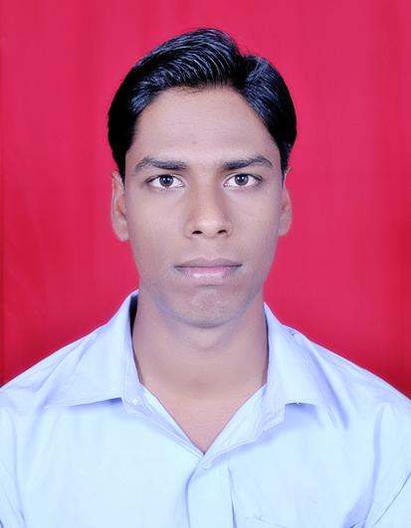
21 P.N Road (GARIA)
Kolkata-700084

Contact No: 7278013789 / 8017266932

Email ID: rakesh.malkera238@gmail.com

RAKESH KUMAR GUPTA
=======================================================================

CAREER OBJECTIVE:

To work in a professional environment with a growing and dynamic organization that would give enough opportunities to learn something in this competitive world and can do something better for organization and self

ACADEMIC QUALIFICATION:

- Completed B.A under H.V.D.U securing 53% in the year 2012
- Completed 10+2 (I.Com) under J.A.C securing 43.4% in the year 2006
- Completed 10th under J.A.C Securing 34.8% in the year 2004

EXTRA QUALIFICATION:

DESKTOP CERITIFIED FROM WIPRO INFOTECH

EXPERINCE:

- Worked in Remote support executive in the Bello Vista technologies pvt ltd as for 5 months.
- Working Desktop support Engineer at DHL EXPRESS INDIA PVT LTD PROJECT OF WIPRO UNDER RASPL From 01.01.2013 till date.

Posted at DHL EXPRESS INDIA PVT.LTD:

- Help desk analyst, an operations analyst and administrator in supporting computer users.
- Desktop Support (Installation, Configuration & Manage) of Windows7 Enterprise.
- Managing IT Vendors like Dell, HP, CANON ESTECH.
- Support for Blackberry Mail Configuration through Enterprise Activation.
- Managing IT inventory including software.
- Microsoft Outlook 2007 and 2010, Configuring & Troubleshooting
- VPN installation and Troubleshooting.

PROFESSIONAL QUALIFICATION:

- Jetking Certified Hardware & Networking Professional from Jetking Infotrain Ltd at kolkata.
SKILLS:-
      - Computer Hardware (A⁺) & Operating Systems : -
Well Knowledge on PC components, Windows XP, Windows 7& Windows 2008 Server Operating System.
      - Network Essentials (N⁺): -
LAN topologies, Cabling, TCP/IP protocol suit.
      - Microsoft Windows Server 2008 Environment (MCITP): -
VPN, DNS, DHCP, Domain users/groups.
      - Office Software:-
MS- Office (MS-Word, MS-Excel, MS-Outlook).

PERSONAL PROFILE:

- Father Name : Arun Ram
- Date of Birth : 15th Oct 1988
- Nationality : Indian
- Hobbies : Playing cricket , watching movies, suffering net
- Language Known : English, Hindi, Bengali
- Permanent Address : Vill -Malkera 4 no., P.O-Malkera, Dist - Dhanbad
(Jharkhand), PIN-828304

DECLARATION

I hereby, solemnly declare that all of the above statements made in are true to best of my knowledge and belief. I bear the responsibility for the correctness of the above-mentioned particulars.

Place: RAKESH KUMAR GUPTA
Date:

