Y VASUDEV RAO
G - 28, Mecon Colony
Doranda Ranchi
Jharkhand
Pin -843002

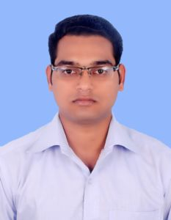
Objective:
To work for an organization this provides me with ample opportunities to grow as a person as well as a team through which, I would like to become an asset for my Company.

Educational Qualification:
Degree | College/Institution |  |  | University/Board | Year of passing | Percentage
B.COM (ACCOUNTS HONOURS) | GOSSNER COLLEGE |  |  | RANCHI UNIVERSITY | 2011 | 64.88
12th (COMMERCE) | D.A.V. JAWAHAR VIDYA MANDIR |  |  | CBSE | 2008 | 52.6
10th | D.A.V. JAWAHAR VIDYA MANDIR |  |  | CBSE | 2006 | 69.2
Strengths :
- A Good Learner And Observer and Problem Solving Ability.
- Positive Attitude, Result Oriented Decision Capability and Good Team Worker.
- Ready to take responsibility.

Computer Skills :
Elementary Knowledge of Microsoft Office, Microsoft Windows 98/ XP/ vista /window7, Adobe, Tally. ERP9
Work Experience :
Organisation : Chinmaya Mission Trust (NGO)
Work Duration: 1st August 2012 to 31st March 2015. Designation: Computer Operator.
Work done : (1) Maintaining Company Accounts. (3)Promotion Activities.
(2)Stock management. (4)Handling Company Affairs (salary to staff)

Professional Traits
- Willingness to work in team and hard worker.
- Ability to deal with people.
- Disciplined & good etiquette.

Personal Information :
Date of Birth : | 15th July 1989
Father Name : | Sri Y.K.REDDY
Mother Name : | Smt. Y.JANKI
Permanent Add : | G-28 SHYAMALI COLONY DORANDA RANCHI JHARKHAND- 834002
Marital Status : | Single.
Hobbies: | Cricket,Badminton,Playing PC Games,Drawing,Net surffing,Reading Books.
Language | English, Hindi, Telugu
Contact : | vasurao.0o7@gmail.com /+919162185205

Declaration :
I here by declare that all the information furnished above is true to the best of my knowledge and belief.

Date:
Place: Signature
(Y VASUDEV RAO)

