MANDIRA HAZRA

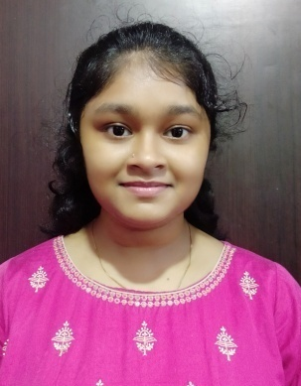

**Mail ID : mandirahazra732**[**@gmail.com**](mailto:aditibhattacharjee11@gmail.com)

**Mobile: 7003738587**

|  |
| --- |
| OBJECTIVE |

Look for new challenges in the practice of Information Technology and related domains.

|  |
| --- |
| ACADEMIC QUALIFICATION |

|  |  |  |  |  |  |
| --- | --- | --- | --- | --- | --- |
| ***Sl. No.*** | ***Name of the Institution*** | ***Name of the Examination*** | ***Board / University*** | ***Year of Passing*** | ***Percentage*** |
| 1 | Narasinha Dutt College | B,Sc  (Computer Science, Hons) | Calcutta University | 2020 | 58.6 |
| 2 | Makardah Bamasundari Institution | Higher Secondary  (10+2th) | West Bengal Council Of Higher Secondary Education | 2017 | 68.6 |
| 3 | Dasnagar Chapala Devi Balika Vidyalaya | Madhyamik  (10th) | West Bengal Board of Secondary Education | 2015 | 79 |

|  |
| --- |
| ACADEMIC LANGUAGES |

**C Language, C++**.

|  |
| --- |
| ***OTHER QUALIFICATION*** |

Completed 6 months **Python course** from **Aptech Computer Education** – Saltlake Centre.

|  |
| --- |
| *PERSONAL INFORMATION* |

|  |  |
| --- | --- |
| **Date of Birth** | 07th March,2000 |
| **Nationality** | Indian |
| **Sex** | Female |
| **Marital status** | Unmarried |
| **Languages Known** | Bengali (Mother tongue), English, Hindi. |
| **Hobbies** | Cooking, Reading Books, Net Surfing, Listening to Music and Knowing more about new things of my interest. |

|  |
| --- |
| STRENGTH |

Extremely Energetic, Flexible, Eager to know news things & try those in practical.

High Concentration level, Good team work, Manage any kind of situation.

***DECLARATION:***

I hereby declare that all the above information is true to the best of my knowledge and belief.

**DATE**: 03/09/2021

**PLACE**: HOWRAH