Curriculum vitae

***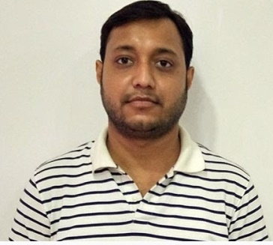*MD.AZAHARUDDIN**  
**Contact No:** 9031059866, 8709300282   
**Email:** sunnyazahar@gmail.com

**CREATE OBJECTIVE**

Major Characteristics- Ability to understand the Requirement and works as a proficient team member. A Keen-learner with strong inter-personal and analytical skills.

**Academic Qualification**

* **BSc (IT)** **from** KUVEMPU UNIVERSITY (2014).
* **Intermediate From** B.S.E.B Patna Board (2010).
* **High School from** B.S.E.B Patna Board (2008).

**Professional training**

* **18 Month** Higher Diploma in Software Engineering from NIIT ,PATNA

**Key Skills**

PHP, HTML, CSS, JAVA Scripting, J Query, C, C++, My sql, AJAX, CodeIgniter, Laravel

**Work Experience**

**Feb 2014 - March 2016**

**Tech Support**

Fino Pay Tech Pvt.Ltd

Ranchi (Jharkhand)

During campus placement, I was selected in **Fino Pay Tech Pvt.Ltd**, as tech support in RSBY Project.

**May 2016 – May 2018**

**Junior Web Developer**

Niks Technology Pvt.Ltd

Patna Kankarbagh

I was selected in Niks Technology Pvt.Ltd, as Junior Web -developer.

**May 2018 – July 2020**

**Web Developer**

Mobapps Technologies Pvt.Ltd

Noida Sector- 59

I was selected in Mobapps Technology Pvt.Ltd, as Web -developer.

**Aug 2020 - Now**

**Web Developer**

Webmobril Technologies Pvt.Ltd

Noida Sector - 63

I was selected in Webmobril Technologies Pvt. Ltd, as Web -developer.

**Personal Strength**

Self- motivated and a good team player.

Excellent understanding of Project issues, Ability to work efficiently under constraints.

Good Analytical skill and Technical documentation skills.

**Personal Detail:**

* Father’s Name :MD.JAMALUDDIN
* Mother’s Name :SAFINA
* Date of Birth :22/11/1993
* Marital Status :Single
* Language : English, Hindi.
* Nationality : Indian.
* Hobby : Playing Cricket and Listening song.
* Address : Vill+PO-Jagdishpur,

Dist- Bhojpur, (Bihar),

802158

*I hereby declare that the above information given by me is true to the best of my knowledge.*

Date: ---------------- Signature:

Place: -------------------