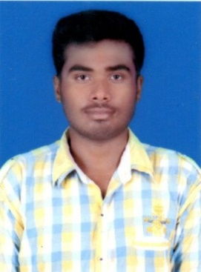**CURRICULAM VITAE**

**SOUFAJIT BISWAL**

**Mob: -+91 9337998974, 9777878332**

**Present Address:**

**At-Tulanga, Po-Tulanga**

**Via-Tirana, Dist-Jagatsinghpur, Pin-754138**

**Email: -soufajitbiswal@gmail.com**

**Career Objective:-**

* To Main Objective of my life is to achieve the goal of my career, always to be hard work for my organization. I believe in some creative work to be leading my organization. Putting all my efficiency to pull high scope of organization.

**Academic Profile:**

* B.SC Graduation (Balikuda Degree College, Balikuda) Under Utkal University Odisha in 2018 with 50.64%
* 12th (Science) passed (S.S.J Mahavidyalaya, K.C pur) Under CHSE Board Odisha in 2015 with 43.33%.
* 10th passed (Satyanarayan High School, Alana) Under BSE ODISHA in 2013 with 62.66%.

**Technical Profile:-**

* HTML, CSS, WordPress, C, C++, PHP

**Language: -**

* Hindi.
* English.
* Oriya.

**Strengths**:-

* Confidence, hard working.
* Honest.
* Punctual & sincere.
* Good Communication Skills.

**General Skill: -**

* Having pleasant personality with good communication skill
* Having Strong determination and vision.
* Good interpersonal relationship and man of integrity.
* Ambitious, aggressive and positive attitude.

**Area of Interest: -**

* Reading Newspaper.
* Listening Music.
* Playing Volleyball.
* Learning New Technology.

**Personal Profile: -**

* Father’s Name : Shribas Biswal
* Mother’s Name : Rinarani Biswal
* Date of Birth : 5th mar 1998
* Gender : Male
* Marital Status : Unmarried
* Religion : Hindu
* Nationality : Indian

**Declaration**:-

I hereby declare that me above mentioned details are true to the best of my knowledge and belief.

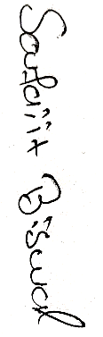

Date:

Place: Jagatsinghpur (*Signature of Applicant)*