**SHANU ADHIKARI** 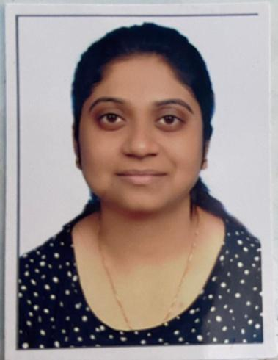

RZ 88 B Manas Kunj

Uttam Nagar East

Delhi

8877339129

[Shanuadhikari05@gmail.com](mailto:Shanuadhikari05@gmail.com)

<https://www.linkedin.com/in/shanu-adhikari-2496b5129>



Work as a GIS Executive in Techculture and be responsible to build and maintain GIS databases and use ArcGIS software suite and other techniques to provide a better understanding of certain variables in a given geographic location.

**QUALIFICATION :-**

M.sc – Geoinformatics From – Birla Institute Of Technology- Mesra, Ranchi

Graduation – Bachelor of Arts – Geography- Hons – Ranchi University

**INTERN**

Company – **Wadia Institute of Himalayan Geology** Job Role – INTERN -From 20th May to 4 July 2017 “Geoinformatics Base study of surface morphological changes in Chorabari Glaciers, Uttrakhand Himalaya “(1962-2013) Layer stacking , Mosaicking of Study Area ∙ Creation of AOI for the study area ∙ Detect The changes that has taken place between 1962 to 2016∙ Creation of longitudinal profile.

**GIS Professional Skills**

* Excellent database knowledge
* Arc-GIS 10.7
* ERDAR IMAGINE 2015
* QGIS 3.10
* Global Mapper

**Professional Experience**:

Company – TECHCULTURE –( 2 yrs)

Job Position- GIS –EXECUTIVE

**Job Responsibilities:**

Utilize Geographic Information system techniques to provide a better understanding of certain variables in a given geographic location.

* Geo-reference satellite image data
* Ability to design of proper grid and projection for the assigned region
* Digitize physical features including vectorization, symbolization layering
* Edge matching/topological integrity.
* To generate large scale and detailed base maps under different layers such as plot building ,boundaries roads, important landmarks.
* Ability to geo code manual survey data in base map.
* QA/QC
* Extract data from GIS software and use varying analysis methods to arrive at result

**Declaration :**

I, hereby declare that the above statements made are complete and true to my knowledge and belief.

Date:

Place : Delhi **Shanu Adhikari**