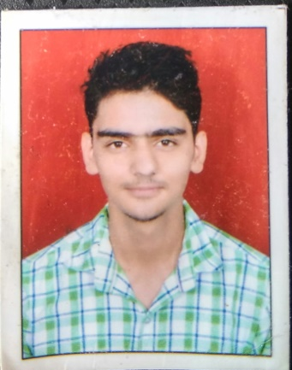

Ashish Chaudhary

# Kharkhoda District Sonipat.

Haryana, India

Mobile: (+91 8295831389)

E-mail: ashusindhu122@gmail.com

**PERSONAL STRENGTH**

Good team worker self-motivated and result orienteer, willing to accept challenges, highly ambitious, passion and regards for my profession to achieve in planned manner.

**Education**

|  |  |  |  |
| --- | --- | --- | --- |
| **Course/Degree** | **College Name/Board** | **Year of passing** | **CGPA/Percentage** |
|
| MSc in GIS and Remote Sensing | SSJ Campus (KUMAUN UNIVERSITY) | 2018 | 73% |
| BA Geography (Hons) | Bhim Rao Ambedkar College (DELHI UNIVERSITY) | 2016 | 73% |

* **Project** : “Remote sensing and Gis services for identification of new schema of 1 to 10 ha of upper Shillong East Khasi Hill District, Meghalaya”
* Monitoring, Using Remote sensing & GIS technique (ArcGis+Erdas Imagine)

**SEMINAR/CONFERENCES**

* Poster present on “estimation of PM10 over Dehradun City, Uttarakhand” International Geographical Union (IGU) Commission Seminar organized by, Department of Geography B. BOROOAH COLLEGE, GUWAHATI, ASSAM, INDIA.

**EXPERIENCE: -**

* TOTAL EXPERIENCE 2Years 6month (India) 6Months **(EDIC BAYANAT,UAE)**

**RMSI Pvt.Ltd**

**GIS Engineer**

* 3D Feature extraction from stereo image
* 3D City modeling(ESRI City engine)
* Statistical Data analysis.
* Input preparation of satellite image(layer stacking, Projection system,mosic,subset)
* ArcGIS user 10.1 as Operator
* Ortho Rectification of Aerial Image.
* Extract Buildings and Roads from satellite Image.
* Geocoding
* Topology, Data finalization and Data conversation.
* DEM creation from cartosat image
* Land form mapping using DEM
* Creation Landscape ecological Unite
* Create soil map using interpolation method.
* Change detection of jhum cultivation

**Software Skills**

* Good User (ARC GIS + stereo view) Software (2D \ 3D)
* Good User (Erdas Imagine) Software.
* Good User In Datum.
* Very good knowledge on Satellite image processing and interpretation (FCC).
* Good knowledge in FME Work station
* Familiar with Micro station and ENVI Software
* Statistical analysis.

**Personal Information**

* Date of birth: 04/08/1994
* Marital state: Single
* Military status: Exempt