CURRICULUM VITAE

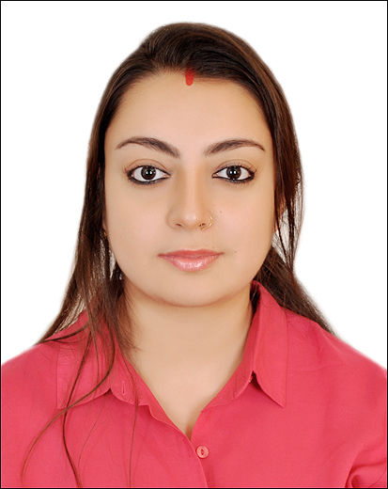

JATARUPA SARMA UPADHYAY

Email id: sarmajatarupa@gmail.com

Mob. No.: 919560156396 ,917577037168

Munirka, New Delhi

**WORK EXPERIENCE**:

**Junior technical officer**: Sept 2015 to May 2016 in **ENGEO CONSULTANCY & RESEARCH CENTRE**, Guwahati, India.

**Responsibilities:**

* Digitization in AutoCAD and ArcGIS.
* Collection of data from Google earth with the help of grid provided.
* Taking coordinate points and snaps from Google Earth.
* Building of topology of the roads digitized and correction of errors in it.
* Georeferencing of digital maps and making layout

**GIS Engineer** : Sept 2017 to Dec 2018 in **Trimble Information Technologies Private Ltd**

Chennai, Tamil Nadu

**Responsibilities:**

Customizing Road utility mapping for US and Mexico.

Working on feature class datasets using multiple sources (INEGI, Bing Imagery and USGS WMS Layers)

Creating and updating Road network as per the navigation rule for routing

Attributing and classing as per the specification of the project

Server based GIS data editing, Data Conflation with existed road network

Using customized open source tools (QGIS) to develop the geographical data

Performing QA/QC process for road network to ensure the quality of Road network for proper routing

**GIS intern:** Sept 2019 - November 2019 at Viz experts Mahipalpur, New Delhi

**Responsibilities**

Digitisation on QGIS

**GIS freelancer:** August 2020 at VIZENT SOLUTIONS PRIVATE LIMITED, Gurugram, Haryana

**Responsibilities**

Golf course mapping and working with the updation work (distance lines, elevation points, hazards, correction of tees) on shotscope and stracka software

TECHNICAL QUALIFICATION

COMPUTER/SOFTWARE SKILLS: MSOffice, ArcView, ArcGIS, ENVI, ERDAS Imagine, Global Mapper and

QGis.

ACADEMIC QUALIFICATION:

|  |  |  |  |  |
| --- | --- | --- | --- | --- |
| CLASS/COURSE | INSTITUTION | BOARD | YEAR | DIVISION |
| M.Sc. Applied Geography | University of madras,  Chennai | University of Madras | 2013-15 | 1ST |
| B.A Geography | Cotton college,  Guwahati | Guwahati University | 2010-13 | 1ST |
| Intermediate | Gurukul Grammar Senior Secondary School,  Guwahati | AISSCE | 2010 | 1ST |
| Matriculation | Maharishi Vidhya Mandir,  Mangaldai | AISSE | 2008 | 1ST |

ACTIVE PARTICIPATION IN VARIOUS SYMPOSIUMS/SEMINARS:

* Participated in the 35th Indian Geography Congress on “Sustainability, Environment and Society” conducted by University of Madras, Chennai.
* Participated in the National Seminar on Shifting Cultivation.
* Attended lecture conducted by Professor Shah Nawaz and Professor Bala Krishnan.

EXTRA CURRICULAR ACTIVITES:

* Diploma in Bharatnatyam.
* Social worker (worked in an NGO)

PERSONAL SKILLS:

* Good Communication Skill in English, Hindi and Assamese,
* Willingness to learn.
* Optimist, hard worker and helpful.
* Job Oriented & passionate.

PERSONAL PROFILE:

**Nationality:** Indian

Marital Status: Married

**Religion:** Hindu

**Gender:** Female

**Date of Birth:** 24th November 1991

* **Hobbies**: **Listening** Music, Travelling, Cooking, and Playing Badminton
* **Languages Known**: English, Hindi and Assamese

REFERENCE:

1. Dr. R.N. Sharma: CEO, **ENGEO CONSULTANCY & RESEARCH CENTRE**, Guwahati, India

**Mob No**: +91 9435043171 **Email id**: ceo@engecorc.com

**2**. **Mr. Uday Kumar: Team Leader, Trimble Information Technologies Private Ltd**, Chennai,

Tamil Nadu. **Mob no**: +919743128954