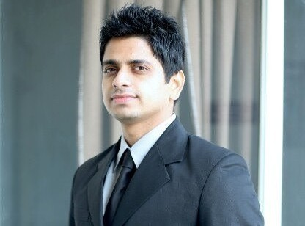

**RAJESH MEHRA**

**9953681406 EMail**:[mehrarajesh08@gmail.com](mailto:mehrarajesh08@gmail.com)

**Objective**

To better facilitate and serve the organization in all possible areas.

**Education and Certifications**

* Certified **MSME’s trainer.**
* Cleared **UGC-NET** examination in June 2011
* **M.B.A** in 2010, from Guru Gobind Singh Indraprastha University New Delhi.
* Bachelor in Commerce in 2006 from Delhi University.
* Higher Secondary School Certificate in 2002 from CBSE.
* High School Certificate in 2000 from CBSE.
* M.S. Office and Internet course from YMCA New Delhi.

**Work experience:**

1. Working with **Anulekha Society** as **Coordinator-PME&L(Planning, Monitoring, Evaluation and learning)** from 01.04.2016 and **Assistant-Capacity Building** from 15.07.2013 to 31.03.016

Job responsibilities;

* + 1. Develop proposals for new projects under livelihood, education and women empowerment programs.
    2. Prepare curriculum for the projects.
    3. Prepare procedure and processes for monitoring and evaluation.
    4. Design assessment survey like pre & post training, base line, mid line & end line assessment as per the requirement of the project.
    5. Supervise data entry of collected data and quality.
    6. Evaluate the learnings for future decision making.
    7. Use learnings for better implementation and improvements.
    8. Systematic Program audit to ensure the smooth functioning and adherence to procedures.
    9. Preparation of capacity building training modules for children, women and adults.
    10. Prepare formats for recording feedback from beneficiaries for quality of training programs.
    11. Train TMO (training and monitoring officers), youth mentors and community peers.
    12. Organize, conduct and monitor community training programs and sessions.
    13. Design strategy and framework to assess the outcome of capacity building programs.
    14. Preparation of donor reports as per standard formats.
    15. Preparation of case studies and success stories.
    16. Allocate work to interns from diverse background.
    17. Preparation of gap and variance analysis reports.
    18. Content creation for social media and newsletters, annual reports.

1. Worked with **Dr. K.N.Modi University** as **Assistant Professor-Management** From 02.07.2012-12.07.2013.

**Research papers presented/workshops/seminars attended**

* Indian women-safety & empowerment in 21st century” published in International journal of engineering, research & development, Volume 2 Issue 2, June 2014, page-2702- ISSN2321-9939
* “FDI in insurance sector” published in International Research Journal for intellectual Science and Management May 2013 Issue page-42-60 ISSN 2320-656X
* Research Paper presented in national seminar organized by CMD(Centre for management & development), Modinagar entitled “Valuation of Human Capital.
* Attended workshop on entrepreneurial skills development organized by NEN at Jaipuria Institute of Management, Jaipur
* Attended workshop on entrepreneurial skills development organized by NEN at VIT Campus, Jaipur

1. Worked with **“Magic Bus India Foundation** as “**Officer-Administration**” from September 2010 to June 2012.
2. 13 months work experience with **Sant Motors Pvt. Ltd**. as “**Accounts Assistant**” (July 2007-July 2008)

**Personal Details:**

**Languages known :** Punjabi, Hindi, English

**Permanent Address :** T-22 Second Floor, West Patel Nagar, New Delhi-110008

**Date of birth : 16.01.1984**

**References**

**Ramraj Maurya -Magic Bus India Foundation 8130380888**

**Radhika kapoor-Anulekha Society 9811202929**