**C.V. ADV. ANKIT SHARMA**

***PERSONAL INFORMATION***

Name: Ankit Sharma 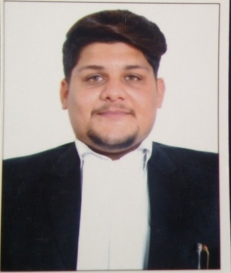Enrollment No: D/3879/2016

Date Of Birth: 20_ 05 – 1992

Address: 1/3370 Ram Nagar Extn. Shahdara

Delhi-110032.

Office Address: Chamber No. D-218, Lawyer’s Chamber

Karkardooma Court, Delhi-92.

Ground Floor 1/3370 Ram Nagar Shahdara

Delhi-32

Mobile: 8178400712

Email: adv.ankitsharma007@gmail.com

***OBJECTIVE***

Looking for an excellent opportunity to work as an legal professional where my talent and knowledge can be utilized for providing justice.

***PROFILE***

I am an enterprising young professional with 5 years of extensive experience in the field of legal and intending to continue my advocacy as a legal consultant. I think in terms of results objectives, I am enthusiastic and I work with decisiveness and conviction.

***QUALIFICATION***

Bachelor of law from Maharishi Markandeshwar University, Ambala Haryana with 1st Division.

Pursuing LLM 2nd Year from Garhwal University, Kotdwar Uttrakhand

***PROFESSIONAL EXPERIENCE***

18/02/2014 STATE CONFERENCE OF LEGAL FRATERNITY

22/07/2015 to 04/08/2015 INTERNSHIP UNDER DISTRICT LEGAL SERVICES AUTHORITY (AMBALA)

Practicing as an Advocate from last 5 years in all District Court and Delhi High Court.

***LANGUAGE PROFICIENCY***

Hindi and English

(ADV.ANKIT SHARMA)