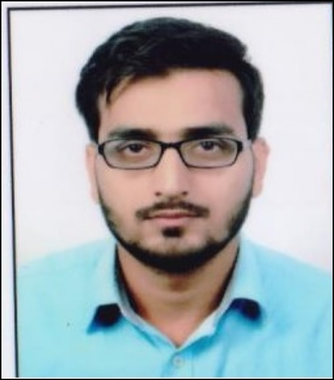

**CURRICULUM VITAE**

**CHANDRA PRAKASH MISHRA**

B-52, Nandpuri, Hawa Sadak, Jaipur - 302006

Contact: +91 9015425689, +91 9415272154

**Email: chandramis@gmail.com**

**CAREER OBJECTIVE:-**

I have more **2.7** years working experience in the field of GIS, Remote Sensing good exposure and practically in satellite data in 2D and software particularly used **Arc GIS, ERDAS Imaging, QGIS,Global mapper** work in an exciting and professional environment of an organization and achieve excellence through dedicated efforts, I am committed towards developing my career and skills gained from experience and study of GIS into practice as a professional GIS Engineer in a dynamic, fast paced GIS business consulting environment.

**EDUCATIONAL CREDENTIALS:-**

* **PG Diploma in Remote Sensing and GIS from Banaras Hindu University in Year 2016**
* **M.SC (Geography) from Kurukhetra University, Kurukhetra (HR) in year 2015**
* **B.A (H) (Geography) from Delhi University, Delhi in year 2011**
* **Higher Secondary from CBSE Board, Delhi in year 2008**
* **High School from Bihar Board, Patana in year 2006**

**WORK EXPERIENCE SUMMARY:-**

* Working As a GIS Excutive on **MJSA Project (Mukhya Mantri Jal Swavalmban Abhiyan)(Government of Rajasthan) Deputed by GIS Consortium india pvt ltd,since 18,june 2018 to** **till date.**
* Working as a Image Processing Expert on project **RajCOMP Survey** in **Department of Information Technology & Communication, Jaipur, deputed by Quantum Asia Pvt Ltd, Since 05, January, 2018 to 20 june 2018.**
* Working As a Image Processing Expert On Project **MJSA Project** **(Mukhya mantri Jal Swavalmban Abhiyan )** **Bharatpur Watershed Department** (Government Of Rajasthan) **Since March 27.2017 to Dec 2018**.
* Working As a Gis Excutive on Project **Government of Rajasthan For RAJCOME Project Jaipur Since July 2016 to March 2017**
* **Nature of Duties:-** Production of Land base mapping Like Road Centerline Building, Using Satellite Image, Geo reference of Village Khasra Map with the help of Google Earth and Online Satellite Imaging with ArcGis, POI Data integration of Rajasthan area,

**RELEVANT WORK EXPERIENCE: (2.7 Year).**

**KEY COMPETENCIES & SKILLS:-**

**Technical Skills:**

**1. GIS Software’s**

* Arc Map 9.3 & 10.1 10.2,10.3,10.4
* Q Gis

**2. Image processing software**

* Erdas Imagine ,Global Mapper

**Microsoft Skills:**

Window XP, Windows-7, Microsoft Office, Microsoft Excel, Power point

**PROJECT SUMMARY**

|  |  |  |
| --- | --- | --- |
| **Project Name** | **Technologies** | **Role** |
| 1. MJSA Project of Government of Rajasthan | Arc Map 10.3,10.5 Global Mapper, Google Earth Pro | GIS Executive |
| 2. RajCOMP Survey of Rajasthan | Arc Map 10.2,10.3,10.4 | Image Processing Expert |
| 3. MJSA Project Of Government Of Rajasthan | Arc Map 10.2,10.3 AS-Built, Google Earth Pro Erdas Imagine | Image Processing Expert |
|
| 4.Rajcome Project of Government Of Rajasthan | Arc Map 10.1, Q GIS , Google Earth, Erdas Imagine | GIS Executive |
|

**PROJECT HANDLED:-**

**QUANTUM ASIA PVT LTD**

**Role: - Gis Excutive**

**Project Name: MJSA Project Government of Rajasthan**

**Description:-** Working on UAV Airborne data for Proposing Suitable site for water harvesting structure

In Selected Watershed of Rajasthan using very high spatial resolution UAV airborne data

For improving agriculture productivity ground water recharge` forest helth as well**.**

**Role: - Image Processing Expert**

**Project Name: - RajCOMP Survey of Rajasthan**

**Description: -** Working on various Satellite image for Land Use and Land Cover Mapping Using Arc Map 10.4, To QC of Lanbase data and Finalization of data

* Land use Extraction using Satellite Imagery as per data model
* POI updation as per data model
* Map Symbology creation as per Rajdhaara portal

**Role: - GIS Expert**

**Project Name: - MJSA Project Government of Rajasthan**

**Description: -** Working on various spatial data for GIs Mapping Georefrence of khasra map Digitization of Khasra Map to Create Village Boundary, ESRI's ArcGIS 10.3 &, Microsoft Office, Exsell Application, Google Earth Pro.

**GIS Data Management**

* **Data Migration**
* **Land base and Mapping**
* **GIS Data Consolidation**
* **Engineering Work Order Posting**
* **Work Order Processing and Posting into GIS**

**Responsibility:**

* The scope of the project is to Analysis, Planning, Implementation
* Data Migration, Field data Verification & Data Maintenance, preparing maps for MJSA Project by using some GIS Platform related Applications as per Client Requirement
* Geo data base Creation on Arc GIS, KMZ Generation using Google Earth

**ADCC INFOCAD LTD**

**Role: - GIS Excutive**

**Project Name: - RajCOMP Project (Rajasthan)**

**Description: -** Working on various Land base Digitization, POI Data Integration or poi data cheek GIS Data Migration,

ESRI's ArcGIS 10.1, 10.3 &, preparing maps for engineers, AutoCAD 2006 & Microsoft Office Application, Google Earth

**Responsibility:**

* + The scope of the project is to Analysis, Planning, Implementation, Data Migration
  + Field data Verification & Data Maintenance for Telecommunication Network by using some GIS Platform related Applications as per Client Requirement
  + GDB Land base features updation using Arial satellite Image

**BANARAS HINDU UNIVERCITY**

Since March-2016 to June-2016 at Barkachha & Surrounding area, Mirzapur, U.P.

**Role: - Dissertation**

**Project Name: -** Remote Sensing & GIS in Dairy Farming and Land use & Land Cover RGSC

Barkachha & Surrounding area, Mirzapur, U.P.

**Description: -** Mapping of, Land Use & Land Cover mapping.

**Responsibility:**

* Land base uploaded
* Land Use & Land Cover Planning.
* Ground Water Potential Zone.
* Operations are carried out in Arc GIS-9.3.

**CORE STRENGTHS:-**

* Optimistic, Self-confidence.
* Ability to think out of the box, want to make a difference.
* Ability to work individually as well as with team.
* Desire to learn.
* Self motivated.
* Can adjust in different conditions.

**PERSONAL PROFILE:-**

**Name** **: Chandra Prakash Mishra**

**Father’s Name : Mr. Tej Narayan Mishra**

**Gender : Male**

**Nationality : Indian**

**Date of Birth : 20 Jun-90**

**Hobbies : Plying Cricket**

**Marital Status : Unmarried**

**Declaration:** - **I hereby declare that above furnished details are true and best to my knowledge.**

**Place: Jaipur (Rajasthan) (Chandra Prakash Mishra)**

**Date: 22th Jan. 2019**