**CURRICULAM VITAE**

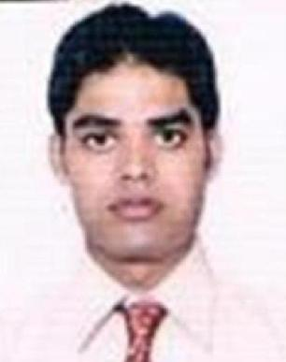

**JAHANGEER ALAM SAIFI**

**India cell: +918791683196, 07410827854**

**Email:** [**jahangeergis89@gmail.com**](mailto:jahangeergis89@gmail.com%20%20%20%20%20%20%20%20%20%20%20%20%20%20%20%20%20%20%20%20%20%20%20%20%20%20%20%20%20%20%20%20%20%20%20%20%20%20%20%20%20%20%20%20%20%20%20%20%20%20%20%20%20%20%20%20%20%20%20%20%20%20%20%20%20%20%20%20%20%20%20%20%20%20%20%20%20%20%20%20%20%20%20%20%20%20%20%20%20%20%20%20%20%20%20%20%20%20%20%20%20%20%20#                     )

|  |
| --- |
| Career Objective: |

To utilize my skill as **Remote sensing , GIS** related fields, correspondence in an optimum way for growing with the organization and accomplish its goals through personal as well as team commitment.

|  |
| --- |
| ****Professional Experience**** |

2+ year of experience in the GIS and Remote sensing. worked for **Navteq India Pvt Ltd/Here Maps** Gudgaon, Haryana, India.

Designation: **Geo-Analyst Feb, 2012- Nov, 2013**

Project**: Navigation**

Project summary:

Worked as analyst Geo-coding, analysis, and Quality of Nav-street database with field collected video drive using Arc GIS, ATLAS tool set. Generation of map report and reporting to the senior managers.

**COWI India** **Pvt. Ltd**. Gudgaon Haryana. **June, 2014- Sep, 2014**

Designation**:** **GIS Associate** Project: **OSGB**

(Ordnance survey data capture and maintenance)

Project summary:

Performed task related to OSGB project, Capturing, editing, maintenance and Analysis of ordnance survey datasets using Arc editor and Arc info software, Overlaying data, running topology, polygon maintenance and other related tool sets for execution of datasets, finally QC of data for quality assurance.

|  |
| --- |
| Academic Qualification: |

**M.Sc**.- Geoinformatics – Barkatullah University Bhopal, M.P. India. (2011)

**B.Sc**. - M.J.P. Ruhilkhand University, Bareilly, U.P. India. (2008)

|  |
| --- |
| Trainings & Certificates |

Six months project training at **National Center for Medium Range Weather Forecasting (NCMRWF),** as partial fulfillment of Degree.

Two months training on Remote Sensing & GIS at MPCST Bhopal organized by IIRS/ISRO Dehradun.

One month training of IIRS EDUSAT outreach program on **“Advanced in Geoinformatics’’** at MPCST Bhopal.

Three days training on Water conservation at Motilal Vigyan Mahavidhaliya, Bhopal M.P.

|  |
| --- |
| Technical skill |

**Geo software:**

* **ESRI GIS:** Arc GIS
* **Remote sensing soft:** Erdas Imagine,ENVI
* **Open source GIS:** Q-GIS, GRASS GIS
* **Other GIS tool:** Auto CAD, GPS, Google Earth, Global mapper.
* **Other tool** : Microsoft office Word , Excel, Power point Out look, Internet.

|  |
| --- |
| Personal Profile |

Sex : Male

Date of Birth : 1st July 1989

Marital Status : Single

Languages Known : English, Hindi, and Urdu

Address : Nagina Bijnor U.P. India

|  |
| --- |
| Declaration |

I hereby declare that all the information given above is true to the best of my knowledge.

Date: (Jahangeer Alam Safi)