MOHAMMAD ASIM 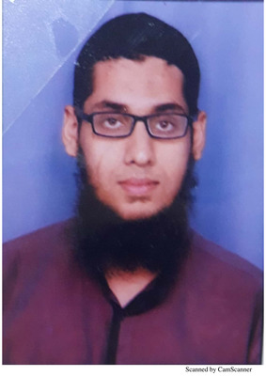

Contact no. 9911330221

Email id :- [masim.system@gmail.com](mailto:masim.system@gmail.com)

H.No. 1646 Gali Sayyadan, Turkman gate

New delhi

**CAREER OBJECTIVE**

* To build a long term career in (specific industry) with opportunities for career growth.
* To enhance my educational and professional skills in a stable and dynamic workplace.
* To solve problems in a creative and effective manner in a challenging position

**EXPERIENCE**

Company name :- System Enterprises

Designation :- accountant & business promoter (online)

Experience :- 2.5 years

Company name :- Paper Planet

Designation :- Accountant

Experience :- 1 year

Current CTC:- 15k

**ACADEMIC QUALIFICATION**

DIPLOMA IN

* 10TH FROM CBSE BASIC COMPUTER COURSE
* 12TH FROM CBSE TALLY ERP 9.0
* B.COM (2015) BUSY

**RESPONSIBILITIES**

* General Accounting
* Gst return filling
* Bank reconciliation
* Financial statement & Reports
* Tds Payment & filling Return
* Inventory Accounting
* Maintaining Payroll
* Creating MIS(pivot table, Vlookup, Hlookup)
* E Tendering on GEM & other portals
* Business promotion
* Email & letter writing

**PERSONAL DETAILS**

Job title :- Accountant

Age :- 26 years

Father Name :- (late) ABDUL MATEEN

Nationality :- Indian

Gender :- male

Marital Status :- unmarried

I here by declared that all the information Provided by me is true to the best of my Knowledge and Belief.

Date:-

Place:-

---------------------

Signature