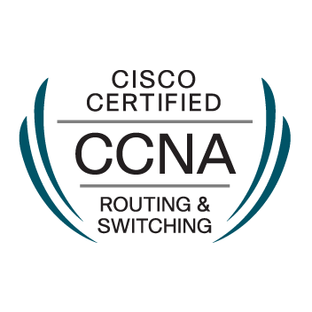 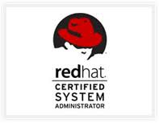

**Mr. Ajay Ambadas Shinde**

Contact:-91-9834155867

Email ID:[-shindeajay0240@gmail.com](mailto:-shindeajay0240@gmail.com)

Address -Flat No-A-1104, IMPERIA, Opp. Abhya CNG

Pursuing Village Road, Pursuing Pune.412308

**JOB OBJECTIVE:**

“To make a good contribution to organization I work for, my capabilities, knowledge and experimental skills and achieve satisfaction of creativity, career progression and personal development.”

**Work Experience**

**Designation**:  **As a System Engineer.**

**Organization     :  Open View Technology Pvt Ltd Pune**  
**Duration             :** 25 Nov 2019 to Till Date .

**Job Responsibilities**

* Installation & Configuration of Red hat, Ubuntu, Fedora, Kali Linux, and Windows Xp,7,8,8.1,10.
* Install and Configure Linux or Windows Systems.
* Should have strong OS administration skills on Linux or Windows.
* OS patching skills on Linux And Windows.
* Experience in Server Hardware Knowledge, Monitoring & Administration.
* Troubleshoot server network configuration problems Linux & windows.
* Applying operating system updates, patches, and configuration changes.
* Manage Anti-Virus / Security setup including Server and client deployment
* Mainly handling networking of LAN, IP address, configuration of routers and maintenance of all types’ servers & Internet.
* Excellent technical knowledge of current protocols, operating system and standards.
* Assist in managing LAN / WAN networks, including structured cabling.
* Troubleshoot All Types Printer OR Scanner.
* Handling Department Asset Management
* Provided technical supports to end users.
* Design and implementation of Local Area Networks.

**Work Experience**

**Designation**:  **As a Support Engineering.**

**Organization** :  JIVAN VIKAS FOUNDATION  
**Duration             :** 11 April 2019 to 22Nov 2019

* Handling database backups, troubleshooting of MS-SQL servers.
* Installation & Configuration Windows Xp,7,8,8.1,10.
* Hardware configurations and repairs and installs Hp Desk Jet, Inkjet, Dot-Matrix & LaserJet printers and scanners
* Trouble shooting Desktop connectivity, cabling, Switches.
* Interact with vendors for repairs of hardware & Procurement.
* Setup systems as Application and Database servers
* Pc new configurations, modifications built new systems, cat 5 & 6 wiring, maintenance, troubleshooting.
* Making appropriate entries in the log book such as action take report etc.
* Checking Antivirus & Firewall logs on daily basic.

**EDUCATIONAL QUALIFICATION**

* Completed **BE** (computer Science & Engineering) with **62.66 %** from **Deogiri Institute of Engineering,** Dr. Babasaheb Ambedkar Marathwada University, Aurangabad in 2015.
* Completed **Diploma** with **62.00%** from **Hi-Tech Polytechnic College,** Aurangabad in 2011.
* Completed **H.S.C** with **53.00**% from **Maulana Azad College**, Aurangabad, and Maharashtra in 2007.
* Completed **S.S.C** with **67.20**% from **Godavari Public School**, Aurangabad, and Maharashtra in 2005.

**CERTIFICATIONS**

* Completed **“Cisco Certified Network Associate ”** certification on 12 Nov, 2013,**Cisco Id :- CSCO12519965**
* Completed “**REDHAT CERTIFIED SYSTEM ADMINISTRATOR”** certification on 18 Mar, 2015, **Verification Number:-150-029-874**
* Completed **“REDHAT CERTIFIED ENGINEER”** certification on 19 July 2015, **Verification Number:-150-029-874**

**CO-CURRICULAR ACTIVITIES**

* Worked as co-coordinator in various social work such as **“blood donation** **camp” and** associated with **“REMAND HOME” (NGO).**
* Organized various cultural activities in society to create awareness about Indian culture and Indian History.
* Worked as **Discipline Committee Membe**r in Aurangabad 2014.
* Held three year Cricket Team captain-ship in  **“Hi-Tech Polytechnic College”**
* Held three year Cricket Team captain-ship in  **“ Deogiri Institute of Engineering “**

**PERSONAL DETAILS:**

Date of Birth : 21/01/1990

Languages Known : English, Hindi and Marathi.

Permanent Address : Address N-12 F-68, Swami Vivekananda Nagar, Hudco A ‘Bad.

Nationality : Indian

Hobbies and Interest : Playing Cricket, Social Activity, Reading Book.

**DECLARATION:**

I hereby declared that the above mentioned information is correct up to my knowledge and belief.

Place: Pune

Date: Ajay Ambadas Shinde