Curriculum Vitae

Sandeep Kumar

V.P.O - Barsana , Tehsil –Charkhi Dadri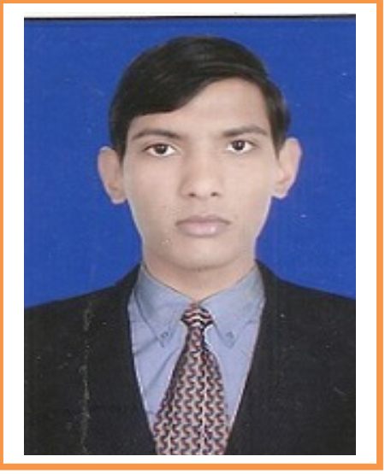

District- Charkhi Dadri , Pin no – 127026

Haryana

Mobile no.- +919812478774

Email: [yadav25258@gmail.com](mailto:yadav25258@gmail.com)

CAREER OBJECTIVE:-

A challenging career which would present an opportunity to make my skills to contribute to the company’s growth by way of continuous learning and upgrading skills and leave room for my further development in the latest and diversified area.

Academic Education

I have passed 10th from HBSE.

I have passed 12th from NIOS .

I have passed BCA from MD University Rohtak.

I have passed MCA from GJ University Hisar.

Work Experience

Two years experience in Networking and system engineer In Birla Education Trust Pilani.

Key Responsibilities Handled

Network redesign for branches / Campus Locations.

Troubleshooting of complex LAN/WAN infrastructure, including routing protocols EIGRP, OSPF & RIP.

Settings of the networking devices (Cisco Router, switches) co-coordinating with the system/Network administrator during implementation.

Worked on L2 and L3 MPLS and internet related bandwidth issue.

installation and configuration of LAN, WAN and wireless network with active components such as routers, switches, modems.

Creating infrastructure of wiring and install network component.  
Design LAN and physical component.

STRENGTHS

I am an enthusiastic, reliable, responsible and punctual person. I am a good worker and adaptable to all challenging situation and dedicated to my work. I have good interpersonal skills. I am able to work well under pressure and adhere to strict deadline.

Te chnical Skills

Configuration of centralize management  ( Client Server Networks) on Windows 2008 server

·Knowledge of creating user accounts and managing through A.D.S

·Working experience on Cisco routers and Cisco switches in (2600 2500 series ) both fixed and modular platforms

·Configuration of Static and default routing

Implementation of Dynamic Routing ( RIP , IGRP , OSPF , EIGRP )

·Configuration and Implementation of VLAN’S on Cisco Switches. (2950 , 1900 )

·Configuration of VTP Modes and Implementation of Inter VLAN Routing

·Knowledge of  STP Algorithms and apply encryptions  and trunking  concepts

Apply Restrictions  Through Passive interface and Implement  A.C.L

(Standard , Extended  and Named ACL)

Configuration of  Static , Dynamic NAT  & Overload ( P.A.T)

·Depth Concepts of Subnetting  of ( FLSM & VLSM ) Environment  And Applied

Supernatting Concepts

Configuration of  WAN Tech. ( ISDN LINE , FRAME RELAY ) and Knowledge of

Encapsulation of WAN links of PPP & HDLC

Knowledge of  Taking  backup of NVRAM and IOS  via TFTP  Server

Hobbies and Interest

Listening Music

Traveling – Exploring exotic hill station and places

Football

Reading Books

Internet Surfing

PERSONAL DETAILS:

**Father’s Name : -** Ramesh Kumar

**Date of Birth : -** March 7,1993

**Marital Status : -** Single

**Nationality : -** Indian

**Salary Expected : -** Negotiable

**Permanent Address :** - Same As Above

**DATE:**

**PLACE:- (SANDEEP KUMAR)**