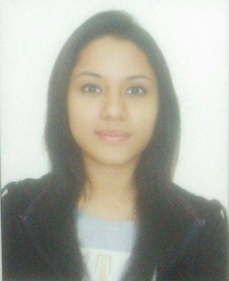

**Ayushi Sharma**

**Contact :** +91-9015140683

**E-Mail :** [ayushi.sharma48@gmail.com](mailto:ayushi.sharma48@gmail.com)

**JOB OBJECTIVE**

Seeking to leverage acquired academic knowledge and work experience to effectively fill your office clerk position . A dedicated worker aiming to help achieve company goals and take on more responsibility as quickly as possible .

**PROFILE SNAPSHOT**

* An enthusiastic fresher with highly motivated and leadership skill.
* Have Positive attitude towards everything.
* Eager to learn new technologies and methodologies.
* An effective communicator and capable of working in a team with good analytical and time management skills.

**PROFESSIONAL QUALIFICATION**

* BCA degree from Jagannath University , Jaipur
* Pursuing MBA from Mangalmay Institute Of Management & Technology.

**EDUCATION**

|  |  |  |  |
| --- | --- | --- | --- |
| **YEAR** |  | **INSTITUTE** | **PERCENTAGE** |
| **2017-2019** | MBA | MANGALMAY INSTITUTE OF MANAGEMENT AND TECHNOLOGY | Pursuing |
| **2013-2016** | BCA | JAGANNATH INSTITUTE OF MANAGEMENT SCIENCES | 64.0% |
| **2012-2013** | 12th | HAPPY SCHOOL , DARYAGANJ | 57.2% |
| **2010-2011** | 10th | HAPPY SCHOOL , DARYAGANJ | 67.5% |

**INTERNSHIP**

Organisation : VMDD, Hackveda

Project : Accessing Application for Android.

Duration : 6 weeks

Description : In this project we learned about how to access the phone of someone else and perform different functions through it.

**ACHIEVEMENTS**

1) Participated in Sports at Jasola.

2) Participated in Fashion Shows.

3) Participated in Sports and Dance in School.

4) Got first prize in collage making in inter-campus competition.

**HOBBIES**

* Watching Series
* Cooking
* Interacting with people
* Listening Music and Dancing

**PERSONAL DETAILS**

Date of Birth : 23rd May, 1995

Permanent Address : 3258 Lal Darwaza Bazar Sita Ram Delhi - 110006

Present Address : 3258 Lal Darwaza Bazar Sita Ram Delhi - 110006

Languages Known : English and Hindi