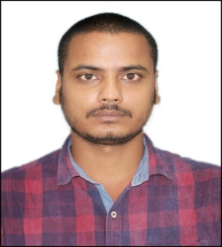

**Present Address:**

H.No-203-2/2, Street No- 11,

Adityapur-2 ,Jamshedpur ,Jharkhand-

831013.

**GAURAV KUMAR JHA**

**MCA-Master of Computer Application**

Contact No. : - +91-894821251.

E-mail:- [gauravjha26121991@gmail.com](mailto:gauravjha26121991@gmail.com)

**CAREER OBJECTIVE**

To work in an organization as a professional, where I can utilize my potential and apply knowledge which will enable me to grow as an individual and fulfill my future endeavors.

**BASIC ACADEMIC CREDENTIALS**

|  |  |  |  |
| --- | --- | --- | --- |
| **Qualification** | **Board/University** | **Year** | **Percentage** |
| MCA | Kolhan University, Chaibasa | 2018 | 68% |
| BSC.IT | Sikkim Manipal University DE | 2015 | 61% |
| INTERMEDIATE | JAC Board, Ranchi | 2009 | 67% |
| HIGH SCHOOL | JAC Board, Ranchi | 2007 | 72% |

**LEARNING EXPERIENCE :**

* + - Company Name :- JUSCO, Jamshedpur.
    - Duration :- 3 Week.
    - Company Name :- DIGIKEY,Jamshedpur
    - Duration :- 3 Months.

**PROJECT**

* Blood bank + Donor Management System.
* Crime reporting system.

**COMPUTER PROFICIENCY :**

* Operating System :- Windows XP,MS-DOS, Vista, Linux.
* Basic :- MS OFFICE, Internet.
* Web Programming :- .NET, HTML, JavaScript, Word Press.
* Database :- MS Access, SQL, MySQL.

**ACHIEVEMENTS :**

* Workshop (cyber security) in ISM(iit),Dhanbad

**INTERPERSONAL SKILL :**

* + Quick Learner.
  + Confident and Determined.
  + Ability to rapidly build relationship.
  + Ability to cope up in different situation.

**PERSONAL DETAILS :**

* Father’s Name :- Gana Nand Jha
* Permanent Address :- H.No-203-2/2, Street No- 11,

Adityapur -2 , Jamshedpur , Jharkhand- 831013.

* Date of Birth :- 26-12-1991
* Language Known :- English & Hindi
* Marital Status :- Single
* Nationality/Religion :- Indian /Hindu
* Interest & Hobbies :- Internet browsing, Playing Cricket, Playing

Volleyball, Listening Music.

.

**DECLARATION :**

I do hereby declare that the above information is true to the best of my knowledge**.**

**Place: Jamshedpur. Gaurav kumar jha**

**Date: (Signature)**