**Ashutosh Gautam**

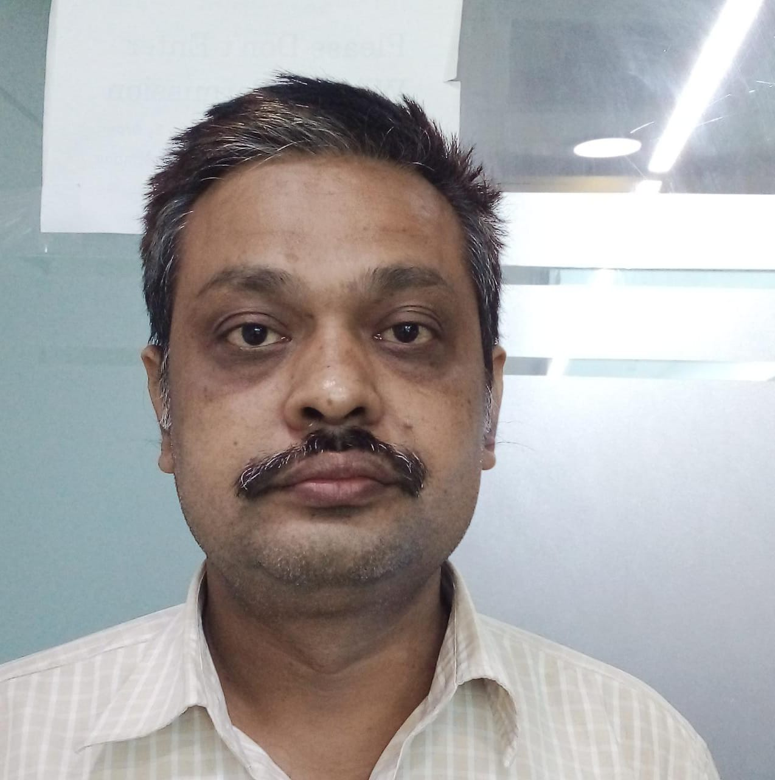

PROFICIENT (ACCOUNTING, LOGISTICS & WAREHOUSING )

**PROFESSIONAL EXPERIENCE**

**(In- Accounting, ware house & Logistics)**

April 2020- Present As **Part Time**

Manager-overall Accounts & Finance along with Stores and administration at **Everain Global Services Pvt. Ltd-**Delhi a Delhi based young Startup working with top level reputed IFS retired from India Govt.

Roles & Responsibilities:

All Tax compliance, ROC, Balance Sheet, Profit & Loss Account, Revenue Forecasting, Budgeting for each project, office Administration, Travel arrangement and Project Tools & Tackles Recording and Maintenance.

June 2014-

March 2020 Project Account Executive, Domestics & Middle east Countries’ Project **Accounting** Stores and Logistics of Material and Human resources Management-at **Nvent inc.** Noida formerly known as **Pentair Thermal Management Pvt. Ltd.** An USA based Electrical Solutions provider for Oil & Gas Companies with turn over Rs.45 thousand Crore.

Roles & Responsibilities:

* Branch Accounting for reginal office at Noida
  + - * Preparation of all type of Vouchers For Accounts & Finance, Preparation of Profit & loss account
* Maintaining **Tally** Prime,
* Managing and recording Performance bank Guarantee, Letter of credits etc.
* GST R-1 & 3B Return filing on monthly basis.
* TDS Deducting & Depositing into banks as per challan.
  + - * Overall Stock & Labor Supply Management of Running Projects at India and Middle East country.
* E-way bill generation for Stock Transfer,
* Procurement (of Labor) & Invoice Verification with attendance & time sheet.
* Review and finalization of Stock Reports.
* Generation of Challan, VISA Stamping, Police Clearance Certificate, Insurance etc.
* Coordination with Vendor for Material and Invoice Verification with Lorry Receipt. Coordination with Procurement & Finance Department for Vendor payment & Goods receipts notes as per PO.
* Reliance and Cairn Energy’s Vendor portal Management for Documents upload and coordination with finance Manager for payment.
* Sea worthy packaging for export of Material.
* Coordination with agent for customs clearance of Stock-Transfer with respect to country of origin.
* Delhi –NCR( Sector-51, Noida)

Image result for mobile sign +91 8744887973

Image result for email signs gautam.ashutosh7@gmial.com

**CORE COMPETENCIES**

* Preparation of all type of Vouchers

For Accounts & Finance

* Preparation of Profit & loss account
* Maintaining **Tally** Prime
* E-way bill generation from GST

Portal for Stock Transfer & Vendor

Supply as per Challan, invoice.

* Stock Transfer from Plant to

Project site or to Ware house

* Keeping stock as per LIFO method

As well as FIFO Method With

Respect to Material Management

* Generating Performa Invoice; Tax

Invoice, Challan as per Lorry Receipt

* Maintaining SAP-Material

Management Module (**SAP**-4.5)

**EDUCATION**

* CFA (Group “A”)-Financial Accounts

& Economics-from ICFAI

Bachelor of Commerce (H)-Accounts

Magadha University, Bihar

**COMPUTER PROFICIENCY**

**Office tools**: Ms Office, Tally, Quick

Book, SAP- Material Management

Module

PERSONAL

Date of Birth- 05th Feb 1979

March 2011-

May 2014 Commercial Assistant-Stores, **TATA power Solar systems** Pvt. Ltd Delhi, formerly Joint Venture with British Petroleum with turn over Rs. One Thousand crore.

Roles & Responsibilities:

* Branch Accounting for Regional Office at UP
* Stock Transfer and Stores of Manufactured goods as well as brought out items.
* Challan Generation for transferring goods to Clients and Stock-transfer.
* Invoice Generation and Road Permit Generation online and receiving Road permit from Client.
* Material Insurance Claim Submission.
* Filing VAT and Sales Tax return with the help of Advocate for UP.
* Coordination for Stock audit.
* Coordinating for Vendor registration

Oct 2008-

March 2011 Associate (Accounts & payroll), **MB BPO solutions Pvt. Ltd.**

Roles & Responsibilities:

* Prepare management plans for USA Based Client
* Monitoring and Performance Accounting of client expenses and Income as well company’s accounting
* UP VAT Return and Bank Reconciliation of Client as well as company.
* Training of Fresher for Quick book operation issues.

2006-2008 Accounts Assistant**, Ganga International** School, Delhi

Roles & Responsibilities:

* Fee Collection and Consumable Stock Maintenance
* Pay Roll Management and Salary Payment.
* General accounting and Cash book Management

Bank reconciliation and stock reconciliation

2003-2005 Assistant Hostel Warden, **Delhi Public School**, Noida

Roles & Responsibilities:

* + - * Stock Maintenance of Hostel consumable.
      * Assessment of boys activity and guiding if any behavior issues.
      * Boy’s attendance in hostel and cleaning staff management.
      * Food quality and quantity Management.
      * Managing boys pocket Money as per there requirement following school guidelines.

Marital Status- Married

Father‘s Name: Mr. Dil kishore Gautam

Nationality: Indian

Language Known: English & Hindi

[**Ashutosh Gautam**]