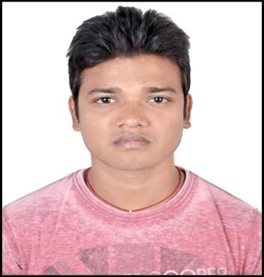 **CURRICULUM VITAE**

**PRAKASH KUMAR**

**EMAIL ID :- Prkshkumar12@gmail.com**

**MOBILE NO** : **+918149316626**

**Present Address**

**Lower Wardhaman compound,**

**Lalpur Ranchi, 834001**

**Career Objective**

To continuously enhance my knowledge, skills and experience by getting involved in challenging work and environment and utilize them for personal and organizational growth to the best of my ability.

**EDUCATIONAL QUALIFICATIONS**

**hjh**

| QUALIFICATION | BOARD/UNIVERSITY | INSTITUTE | YEAR OF PASSING | AGGREGATE % |
| --- | --- | --- | --- | --- |
| B.E. in Computer Technology | R.T.M.N.U. Nagpur University | Priyadarshini College Of Engineering | 2016 | 55% |
| HSC | JAC | RGI College | 2010 | 55% |
| SSC | CBSE | D.A.V Public School | 2007 | 60% |

Technical Skills

* I have done Training on **Cisco Certified Network Associate** **(**R&S) from Zoom Technologies, Hyderabad.
* I have done training and have Knowledge on Microsoft Certified Solution Expert (**MCSE**-2012) and **LINUX** Administration (**RHEL**, **CENTOS**).
* Good understanding of OSI model, TCP/IP protocol suite.
* IP addressing and sub-netting, Routing concepts
* Configuration of routing protocols-STATIC, RIP, EIGRP, OSPF & BGP.
* Extending knowledge of standard & Extended ACL.
* Extensive knowledge of NAT &PAT.
* Hands on experience of CISCO routers backup, Recovery.
* Implementing LAN and WAN connections using SWITCHES and ROUTERS.
* Setup of Layer 2 Switching & STP.
* Configuring and Troubleshooting Frame Relay, RIP, EIGRP, OSPF, VLAN, VPN, TRUNKING, and HSRP & IP Addressing Issues.

WORK EXPERIENCE

* 1 year Experience in Data Entry Operator and Back Office in RIIT Institute, Ranchi

PERSONAL STRENGTHS

* Good communicational skills.
* Sincerity and punctuality.
* Self-motivated.
* Target oriented.
* Positive attitude.
* Hardworking.
* Adaptability.

HOBBIES

* Playing Badminton, Cricket and Playing Computer games.
* Cooking and travelling to different Places.
* Listening music, Taking Photographs.

PERSONAL DETAILS

Father’s Name : Nageshwar Mahto

Date of Birth : 10-Jan-1991

Marital Status : Single

Gender : Male

Nationality : Indian

Permanent Address : At + Po - Rabodh ( Peshrakandi ), Dist- Hazaribagh,

Jharkhand-835330

State : Jharkhand

Language : English, Hindi

DECLARATION

I hereby declare that the above-mentioned information is correct up to my knowledge and I bear the responsibility for the correctness of the above-mentioned particulars.

**PLACE: -** (PRAKASH KUMAR**)**

**Date:-**