## RESUME

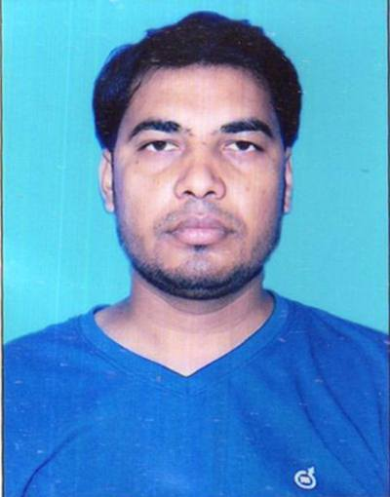

## MD MUSTAQUEEM HASHMI

Bariyarpur west,ps,khudawanpur dist, Begusarai

**Mobile No.** : +91-7250409093/9308310113

Email : mustaqueem4you@gmail.com

|  |
| --- |
| **Career Objective :** |

Seeking a challenging position to utilize my skill and abilities in areas of Front office cash counter or language expert & any work development, which offers a professional growth while being resourceful innovative and flexible.

|  |
| --- |
| **Academic Qualification :** |

|  |  |  |  |  |  |
| --- | --- | --- | --- | --- | --- |
| **S. No.** | **Degree/Course** | **College/School** | **Board/university** | **Year Of Passing** | **Div** |
| **1** | MATRIC | Daru takmil muzaffpur | BEMEB | 2007 | 1st |
| **2** | INTER | Khairul uloom college samastipur | BEMEB | 2012 | 1st |
| **3** | B.A | Central university of jharkhan | UGC | 2016 | 1st |

**Extra Qualification:**

**Strengths :**

* Diploma in Computer Application
* Diploma in urdu language

|  |
| --- |
| **Strengths:** |

* Ability to grasp new technology quickly.
* Willing to do work.
* Maintain punctuality.

**Vocational Training:**

* 15 Days certificate vocational training in CIBER CRIME from CUJ CAMPUS RANCHI

|  |
| --- |
| **Language known :** |

* Read**:** Korean,English,Urdu,Hindi,German
* Write**:** Korean,English,Urdu,Hindi,German
* Speak**:** Korean,English,Urdu,Hindi,German

|  |
| --- |
| **Personal Profile :** |

* Name **:** Md Mustaqueem Hashmi
* Father’s name **:** Md Osamul Haque
* Date of Birth **:** 01, May, 1990
* Gender **:** Male
* Marital status **:** Unmarried
* Nationality **:** Indian
* Permanent address **:** Mohal; Matkora

Vill : Bariyarpur west

P.O. : Tarabariyarpr

P.S : Khudawanpur

Dist. : Begusarai

State : Bihar

Pin : 848202

|  |
| --- |
| **Declaration:** |

I hereby declare that the above mentioned information is correct up to my knowledge and I bear the responsibilities for the correctness of the above mentioned particulars.

Place : **Ranchi**

Date: …………

(Md Mustaqueem Hashmi)