**CURRICULUM VITAE**

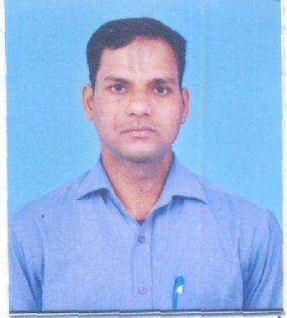**SATISH KUMAR SINGH**

H. No.-2

Bhatia Colony, Ballabgarh,

Faridabad-121005

Contact no-9654775621

E-Mail ID: [satishkumarsingh2@yahoo.in](mailto:satishkumarsingh2@yahoo.in)

**Objective**

* To attain an inspiring and ascendant career of exceedingly knowledgeable professional so as to enable myself to myself to grow along with organization.

**Academic Qualification**

* **M.A** passed from **MJP Rohilkhand University** Bareilly in 2008.
* **B.A** Passed from **MJP Rohilkhand University** Bareilly in 2002.
* **12th**passed From **U.P Board** in 1998.
* **10th** passed from **U.P Board** in 1996.

**Professional Qualification**

* One Year Professional Diploma in Computer Application & Programming from **F-TECH Institute** Ballabgarh Faridabad.
* Three month Course in **Auto Cad** From **C-TECH Computer** Ballabgarh Faridabad.

**Experience**

* I worked as a **Assistant Accountant** with **M/s** **SHREE KRISHNA AUTO INDUSTRIES FARIDABAD** from June -2009 to July -2016.
* I am working as a  **Accountant** with **M/s** **MITTAL AUTO COMPONENTS FARIDABAD** from July -2016 to till now.

**Computer Literacy**

* Microsoft Word
* Microsoft Excel
* Power Point
* Internet
* Tally 7.2 & 9.0
* Auto Cad.

**Job Profile**

* Manage Day to day operation of the accounts
* Billing.
* E-Way Bill Generate
* Account maintain in Tally 9.0
* Voucher prepare
* Bank reconciliation
* Debtor & Creditor Reconciliation
* Balance Sheet Fianlise
* Cash Handling
* TDS ,TCS
* GST
* 57-F preparing.
* Job Work record maintain.
* Returnable/ Non returnable Record.
* Inventory .

**Strength**

* Positive Attitude.
* Good Communication.
* Hard Working.

**Presonal Detail**

* Father’s Name : Ram Veer Singh
* Date of birth : 25-10-1980
* Nationality : Indian
* Marital Status : Married
* Sex : Male
* Permanent Address : Village- Jajpura, Distt- Budaun (U.P.) .

**Declaration**

* I herby declare that the above information is correct to the best of my knowledge.

**Date :**

**Place: Faridabad ( Satish Kumar Singh)**