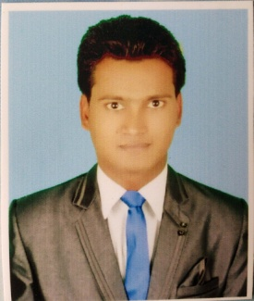**Md Zishan**

**Mobile no- 9852623791, 9939559944**

**Email-** [**mdzishansiddiqee4@gmail.com**](mailto:mdzishansiddiqee4@gmail.com)

**Address:-**

**Laxmi Nagar, Delhi**

**Delhi Pin code 110092**

|  |
| --- |
| **CAREER OBJECTIVE** |
| To obtain an accounting position where I will be able to contribute my skills, knowledge and Experience the organization that will give me an opportunity to develop my career, |

|  |  |  |  |
| --- | --- | --- | --- |
| **EDUCATION** | | | |
| **Qualification** | **Institute/University** | **Year** | **%** |
| ADCA & Tally (Advanced diploma in computer Application & Tally ERP9) | R.K. Training centre, Pandaul,Madhubani,Bihar | 2018 | 82% |
| B. Com | LNMU, Darbhanga, Bihar | 2018 | 50% |
| I. Com | LNMU, Darbhanga, Bihar | 2015 | 67% |
| Matriculation | BSEB,Patna, Bihar | 2013 | 45% |

|  |
| --- |
| **WORK EXPERIENCE** |
| * **Presently working with R.K Associates since April 2018 to till the date** * **Job Responsibilities :-** * **Day to Day Accounting Entries in Tally** * **Credit note Debit note Entries in Tally** * **Vouching with proper head while making journal entries** * **TDS- Calculation, Entries, Challan, Return and Form 16,16A** * **GST-Good knowledge of calculation and Entries** * **Income tax calculation** * **Calculation of P.F,ESI Return and payment and Bonus, Gratuity** * **Salary sheet preparation and salary slip Generation** * **MIS, Sales Report, Purchase Report etc… As per requirement** * **Good knowledge of Word and Excel & Internet also** * **Gapp**   **FUNCTION SKILL** |
| * **Have a knowledge of :** * Bookkeeping, P&L Account and Balance sheet * GST Calculation and Entries * E-filing, GST,TDS,Retun * Internal audit,Statutory audit, Stores audit, |

|  |
| --- |
| **COMPUTER SKILL** |
| * Microsoft office * Comfortable with internet * Tally ERP9 |

|  |
| --- |
| **PERSONAL DETAILS** |
| * Father’s Name: Md Shafiuddin * Marital Status: Bachelor * Date of Birth: 08/12/1996 * Languages Known: Hindi, Urdu, English |

|  |
| --- |
| **DECLEARATION** |
| I hereby declare that the above- mentioned information is true to the best of my knowledge  **DATE :**    **PLACE: Md Zishan Siddiqee** |