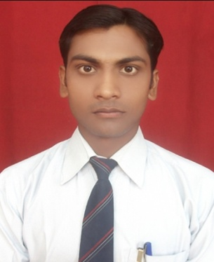

**Resume**

**Pramod Kumar Maurya**

**Mob- +918601389727**

**Email-** [**pramodm34@gmail.com**](pramodm34@gmail.com%20%20%20%20%20%20%20)

**Career Objective:-**

To work in such a company where my skills and ability can be effectively used for achieving Company’s growth and objective.

**Professional Qualification:-**

* **Master in Computer Application** from **Shri Ramswaroop Memorial College of Engineering & Management** **Lucknow (GBTU) with aggregate of 67 % in 2013.**
* Complete **‘A’ Level** from **DOEACC** Society.
* Complete **‘O’ Level** from **DOEACC** Society.

**Academic Qualification:**

|  |  |  |  |
| --- | --- | --- | --- |
| **Class** | **Year of Passing** | **Board/University** | **Percentage** |
| Graduation | 2010 | DDU, Gorakhpur | 46.5 |
| Intermediate | 2007 | U P Board | 49 |
| High School | 2005 | U P Board | 54.5 |

**Technical Skills/Qualification:**

PHP, MYSQL, JAVASCRIPT, HTML, CSS, AJAX

**Experience:**

* I have One Year experience as a PHP developer at Hyper Net It solution Lucknow.

**Key Project Handled:**

|  |  |
| --- | --- |
| **Title** | <www.uti.org.in> |
| **Description** | This website is developed for the purpose of providing all the  Information related to Uma Technical Institute and online enquiry. Channel and  Search the any type of channel news online. |
| **Responsibilities** | * Working on All Module. |

|  |  |
| --- | --- |
| **Title** | [www. hlygpg.com/](www.barasatideviiti.com) |
| **Description** | This website is developed for providing the information related Heeralal yadav  Yadav Balika Degree CollegeChannel and search the any type of channel news online. |
| **Responsibilities** | * Working on All Module. |

* <http://fpbm.co.in/>
* <http://kukiesbasket.com/>
* <http://cdafnda.org/>
* <http://vsjsmahavidyalaya.org/>
* <http://sheelsagarmahavidyalaya.org>
* <http://amaraluminiums.in/>
* <http://soniband.com/>
* <http://www.avadhinstitute.com/>
* <http://madhavpublicschool.org/>
* <http://gciti.in/>
* <http://adityaconstruction.in/>
* <http://imbamup.co.in/>
* <http://balajieducationaltutorials.com/>

**Personal Details:**

**Date of birth :** June 12, 1991

**Mother’s name :** Mrs. Chandrawati Devi

**Father’s name :** Mr. Rajendra Prasad Kushwaha

**Hobbies :** Listening Music, watching movie

**Language Known :** English &Hindi

**Permanent address :** Vill-Sumhi Tola Rampur, Post-Shankar Patkhauli

District.-kushinagar Pin no-274401

**Correspondence address:** Basirat Building, Near Hotel Raj Palace 80/19/20,

Pandariba Lucknow, Near Char Bagh Railway Station

**Date(--/ -- /----)**

**Place: Lucknow (Pramod Kumar Maurya)**