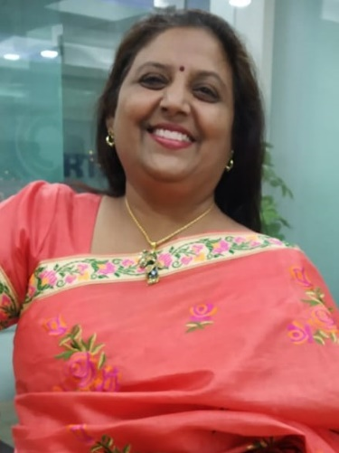**Ms. Vipul Chatterjee**

**CAREER OBJECTIVES**

Seeking **challenging managerial level assignments** in **Back End Operations & Management / Co-ordination with team & Clients (National/ International)/ Customer Relationship Management** with an organization of high repute.

**PROFESSIONAL PREFACE**

* A dynamic professional with **more than 14 years** of experience in **Assisting senior management and Coordination with Team & Clients (National as well as International).**
* Adroit in managing **Back End & Operations and Coordination with Domestic, International suppliers & team.**
* **Conversant with use of various computer** programs and applications.
* Possess **excellent communication and** sharing healthy relationship with management as well as collogues.
* Takes full **ownership of tasks** and makes things happen. Works effectively without constant supervision and overcomes obstacles to complete tasks.
* **Achievement**: Increased overall efficiency by 30% by overhauling the company’s filing system
* **Problem-solving**: Possess strong quantitative **problem-solving** and **prioritization skills**

**AREAS OF EXPERIENCE**

* Reading, researching, and routing correspondence; drafting letters and documents; collecting and analyzing information
* Adept at scheduling meetings, preparing agendas, preparing MOM of the meetings and following up for the action items with the attendees of the meetings
* Travel Management
* Organization of teleconferences for corporate executives, customers and division personnel
* Calendar management
* Back End Operations
* Coordination with customers and internal team
* Working on Google drive

**WORK EXPERIENCE**

* Worked as an Executive Assistant for the CEO of M/s VizExperts India Pvt. Ltd. From Jan 2017 till Sep 2019. VizExperts works for turnkey projects on Virtual reality, Augmented reality, Digital Sand Model, Geospatial intelligence, Audio/Visual video walls.

**My services:**

* Managing CEO’s Schedule, leading to a 7% reduction in nonproductive time
* Acting as a first point of contact
* Organizing 6**+ monthly internal meetings** and their logistical elements (Preparing Agenda, scheduling, preparing the facility, organizing reports from attendees, etc.)
* Preparing MOM of the meetings and following up for the action items with the attendees of the meetings
* Filing of expenses
* Composing and preparing confidential correspondence
* Answering and screening telephone calls in a courteous manner while taking messages with a high degree of accuracy
* Liaise between CEO and subordinates /clients to ensure optimal use of his time
* Provide administrative support to Senior Management
* Handling all domestic and international travel reservations
* Reading, researching, and routing correspondence; drafting letters and documents; collecting and analyzing information
* Supporting CEO in the preparation of all documentation required for key decision making from team members and industry partners by coordinating with different departments.
* Troubleshooting- Ensure to figure out proper solutions for the problem
* Reminding managers/executives for important tasks and deadlines
* Helps in implementing all new processes through google forms
* Perform other general duties as and when required.
* Worked as an Executive Assistant for the managing director of **Syrex Info services India Pvt. Ltd**. A BPO raising funds for different NGO's like UNICEF, CRY, MSF, Water aids etc. from March 2016 to Jan2017

**My services includes:**

* Calendar Management
* Scheduling Meetings
* Reminder of To Do’s
* Maintenance of the attendance of all the managers.
* Delegation and follow ups of various tasks Delegated by the Managing Director to the managers and assistant managers through delegation sheet maintained in excel.
* Answering, screening & filtering the phone calls.
* Filtering, Answering and routing mails and assigns the work as per the mail.
* Worked as an Executive Assistant to the Managing Director at **N. W. Overseas**, dealing in medical and surgical equipment’s, imported from various countries and sold in Indian Govt. and Pvt. Market from March 2009 to Feb 2016.

**My services includes:**

* Coordination – Coordinating between employees and clients - contact key person by phone or email.
* Mails -Reading, replying, routing and delegating tasks as per the requirement
* Travel Arrangements –Domestic as well as International.
* Calendar Management- fixing the meetings.
* Handling Logistic and other related requirements for demo’s of the machinery
* Maintaining data on computer.
* Trouble shooting
* Assisting, coordinating and arranging the required documents for filling various tenders.
* Handling all office activities related to Secretarial, Human Resource and Administration (Handling printing related jobs, e.g. Visiting cards, Letter heads etc.)
* Preparation of salary sheet.
* Maintaining petty cash in the office.
* Verification & Payment of Bills by Due Dates.
* Making Invoices and delivery challans.
* Adopting all measures, practices and procedures to ensure proper dispatch of documents and parcels both, within and out of the office and deal with postal authorities and courier agencies.
* Perform other general duties as and when required.
* Worked for sales promotion of I.T.C. Group of hotels for their various resorts all over India from Jan 2008 to March 2009. Job included development of members in various capacities by offering them the best value for money in their concerned frames.
* Have worked in the capacity of store in charge and computer operator for Bela Trading Engineers, Importers and Traders of spare parts of Industrial Generators, Heavy Earth moving Machinery and their Prime Movers from Feb 1989 to Jan 1994.

My responsibilities included keeping record of all incoming and outgoing spare parts, making out all the proposals and schemes of the company on offer for all their clientele.

**IT SKILLS**

* **Conversant with** MS-Office Applications (Word, Excel & PowerPoint) ,Outlook Express, Microsoft outlook, Google Drive and Internet.

**SCHOLASTIC**

* Short term course for MS office in the year 2005.
* Post Graduate Diploma in Computer Programming & System Analysis from Y.W.C.A of Delhi in the year 1989.
* Graduation B.Com (P) From Delhi University in the year 1987

**PERSONAL DETAILS**

**Date of Birth**: 25th May 1968

**Language known**: Hindi, English

**Gende**r: Female

**Marital Status** : Married