CURRICULUM VITAE

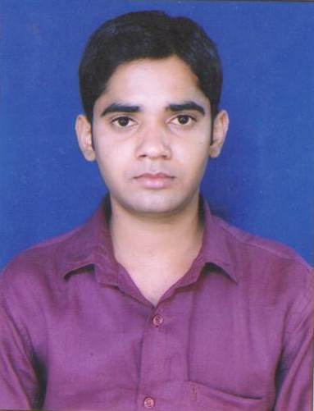 *AKHILESH PATHAK*

**Carrier OBJECTIVE:**

To give the best output by putting my fully devoted efforts with the help of my knowledge, creativity and smart work to the organization to archive the success in a professional manner.

**Academic Achievements:**

2004 Passed 10th from Jharkhand Academic Council. _2ND

2006Passed 12TH from Jharkhand Academic Council. _2ND

2011Completed BCA From IGNOU, Ranchi (2007-2010) _2ND

**EXPERIENCE :-**

* Worked as a supervisor (Vodafone process ) in WEB DATE SYSTEM

PVT. LTD( FROM AUG’15 TO SEP’16)

* Now working as a supervisor (Vodafone process ) in AK GROUP, RANCHI

(FROM 12TH SEP’16).

**Professional Achievement: in** COMPUTER M.S OFFICE, INTERNET

**Personnel Information :**

**Name : *Akhilesh Pathak***

**Fathers Name :** Shri Raghunath Pathak.

**Date of Birth :** 5th SEP.1989

**Gender :** Male

**Nationality :** Indian

**Religion :** Hindu

**Marital status : married**

**Hobbies : playing cricket, listening music &driving**

**Permanent Add : chatter bagicha po+ps+dist-lohardaga**

**(JHARKHAND) 835302**

**Contact Number :** 7808959966,8271500709.

**E-mail ID :** pathakakhilesh59@gmail.com

**Languages Known :** Hindi, English

**Date :-**

**Place :-** (Akhilesh Pathak)