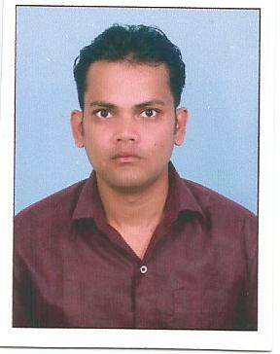CURRICULUM VITAE

# Abhishek Kumar Email:- kumar.abhi236@gmail.com

**abhi.apa236@gmail.com**

**Contact No: -9576164217, 7631176312**

**Objective:**

**I want to work in a challenging atmosphere that provides ample opportunities and growth. I am a young, enthusiastic, hardworking, good knowledge, professional seeking location and an update in my career.**

**Working Experience:**

* **Worked in sterlite foundation as a data operator for six months**
* **Worked in Tata indicom (Swastik Communication’s) as MIS(management information system) for 2 Years.**
* **Worked on Sybex computer as a Data correction and verification operator in census office ranchi for 3 year’s**
* **Worked In SIRD Library As a Computer Operator (Digitalization) For 3 Months**
* **Worked in Luminious Infoways Pvt Ltd as a Dcvo in census office ranchi for 6 months**

**Academic Qualification:**

|  |  |  |  |
| --- | --- | --- | --- |
| **Course** | **University/Board** | **Subject** | **Year** |
| **MATRIC** | **B.S.E.B PATNA** | **All** | **1996** |
| **INTER** | **B.I.E.C PATNA** | **SCIENCE (BIO)** | **1998** |
| **B.SC** | **RANCHI UNIVERSITY** | **ZOO(HONS)** | **2002** |

**PERSONAL SKILLS:**

* **Familiarity with 10-key and alphanumeric typing**
* **Ability to handle multiple tasks.**
* **Can work under pressure.**
* **Can do target based job with efficiently**
  + **Quick learner.**

**Technical Exposure:**

* **Operating Systems :MS Windows 98/XP/2000,MS-DOS**
* **Office Suites : MS Office2007**
* **Diploma in Desk Top Publishing (DDTP)**
* **Diploma in financial accounting (Tally09)**

**Personal Details:**

* **Nationality :Indian**
* **Date of Birth :04.11.1980**
* **Sex :Male**
* **Father’s Name : Shri Ashwini Kumar Dutta**
* **Mother’s Name :Smt Aparna Dutta**
* **Permanent Address : Kutchery Road near Bihar club**

**Bye lane Ranchi Jharkhand pin - 834001**

* **Language Known: Hindi, English Bengali**

**Hobbies:**

* **Interacting with people.**
* **Enjoy playing carom and Badminton& listening music**
* **Watching Movies**

**I hereby affirm that the above information is true to best of my knowledge.**

***Dated:***

***Place: Ranchi***

***(Abhishek Kumar)***