**AamirShafi**

**E-Mail:**khanaamir341@gmail.com**Mobile:** +91 7461069964

**SYNOPSIS**

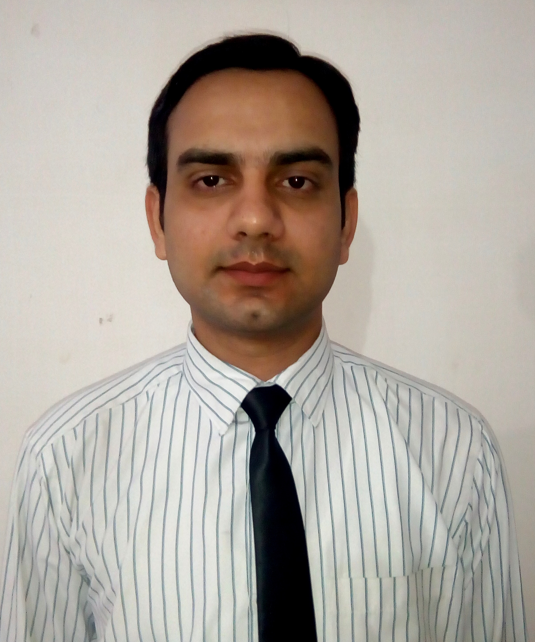

* **Nearly 4 years** of rich experience in **Information & Technology**
* Have excellent, communication and interpersonal skills.
* Capable of leading a team.
* Managing and motivating the subordinates to be result oriented.

**Working as Technical staff in Motilal Nehru Public School from**

**September 2016 till date**

**Primary Role& Responsibilities**

* Handling of server and hardware issues.
* Data entry work
* Question paper typing and report card work through Software.
* Associate work for Principal and Management.

Worked as an **Elite Walker** for the project of **Google map** for **Quess Corp Limited** authorized by **Cognizant Technology Solutions Private Limited** to collect and validate business information in the city of **Jamshedpur** for the period of **25th May 2016 to 30th September 2016** authorized by Google International

**Worked as System Administrator in EducompPvt ltd from 4th Feb 2013**

**28th Aug 2016**

**Primary Role& Responsibilities**

* Handling server 2003
* Maintaining the hardware and software for every digital teaching system assigned in the classrooms.
* Taking timely sessions for the school teachers on the usage of the digital system.
* Dealing with the school heads to take over the contract on behalf of Educomp.
* Maintaining the database monthly report and sharing with the Regional Manager.
* Development of the programs making it user-friendly for new comers.
* Supervising the implementation team, helping in proper installation of the software and serveron time.
* Identifying & applying principlesthat enables continuous quality assurance and process

improvements in serving clients in a better away.

**Worked as System Associate in MetlifeCompany for 6 months in Delhi.**

**Primary Role & Responsibilities**

* Worked in IT Operations
* Used to work on Change Management
* Make tickets of hardware ,software and network tickets
* Attending meetings and making projects.
* Worked through mails and chats.

**EDUCATIONAL QUALIFICATION**

* Graduation in B.Com Honors from Kolhan University, 2012
* Diploma Degree in Interconnecting Network Devices.( **CCNA**), from NIIT Kolkata, 2012
* Diploma Degree in **MCITP**(**Microsoft IT professional**), from Jetking Kolkata,2012
* Diploma Degree in **Hardware & Networking** (**COMPTIA**), from NIIT, 2011
* Diploma Degree in **Hacking & Cloud Computing**, from NIIT, 2011
* H.S.S from ChinmayaVidyalaya CBSE Board ,Jamshedpur,2009
* S.S.C from ChinmayaVidyalaya CBSE Board ,Jamshedpur,2007

**TECHNICAL SKILLS**

* Languages : **C++ and Visual**
* Operating Systems:**Windows7 ,Windows8, Linux, WindowsXP, server 2003,2005**
* Well versed in **MS Word, PowerPoint, MS Excel & Adobe Photoshop**

**PERSONAL DOSSIER**

Date of Birth: 13th December 1989

Fathers Name: Mr. ShafiAlam Khan

Languages Known: English & Hindi

Marital Status: Unmarried

Passport No: **K 1376210**

Address: Flat Alif 304, Mahal Gaon, Mango, Jamshedpur, 831012

**Date: AamirShafi**