` **CURRICULUM-VITAE**

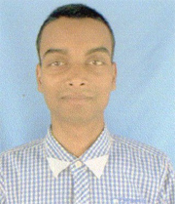**VIKASH KUMAR**

**ADD :- Vill=Geetwas,Post=Geetwas,P.s=Raniganj**

**Distt :- Araria- 854312**

**MoB :- 8051561932,8271264602**

Applied for the post of cashlesh india

**Objective**

To work in highly challenging and Competitive Atmosphere this often growth with opportunity to enrich my knowledge and skills.

**Academic Qualification**

* 10th passed from B.S.E.B, in the year 2008 with 1st Div.
* 12th passed from B.S.E.B, in the year 2011 with 1st Div.

**Technical Qulification**

* Bechlor of Computer Application(BCA)
* BCA passed from jnu jaipur,in the year 2014 with 1st Div

**Personal Details**

Father’s name :- Shri Udranarayan Swarnkar

D.O.B :- 7th March 1993

Sex :- Male

Marital Status :- Unmarried

Language Known :- Hindi & English

Salary Expected :- Negotiable

E_mail Id :- vikashsoni020@gmail.com

**Declaration**

**I do herewith declare that all the above information is given**

**By me is true and complete to the best of my knowledge and belief.**

**Date :- 20/04/2017**

**Place :- Geetwas Vikash kumar**