Name : ASHOK RAJA. S

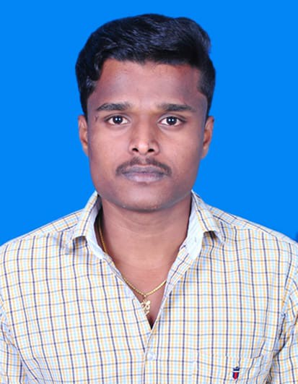

Contact number : +91 86828 78047

Email id [*: ashokraja667@gmail.com*](mailto::%20ashokraja667@gmail.com)

**Permanent Address:**

9C, Psukidaivilai East Street,

Vickramasingapuram,

Tirunelveli,

Tamil Nadu, 627 425

**CAREER OBJECTIVE:**

Seeking for a challenging position as a Civil Engineer, where I can use my planning, designing and overseeing skills in construction and help grow the company to achieve its goal.

**QUALIFICATION:**

|  |  |  |  |  |
| --- | --- | --- | --- | --- |
| **Education** | **Institution** | **University / Board** | **Duration** | **Percentage/**  **CGPA** |
| B.E. Civil | Info Institute of Engineering, Coimbatore,  Tamil Nadu | Anna University | 2015-2018 | 5.90 |
| DIPLOMO | M.S.P. Velayutha Nadar Lakshmi Thaiammal Polytechnic College Tirunelveli, Tamil Nadu | State Board of Technical Educational and Training | 2012-2015 | 85% |
| SSLC | ST. Mary’s Higher Secondary School,  Tirunelveli, Tamil Nadu | State Board,  Tamil Nadu | 2012 | 64% |

**TECHNICAL QUALIFICATION**

* MS OFFICE
* AUTO CAD
* STAD PRO BASIC
* RIVET BASIC

**EXPERIANCE**

* Working as a Technical Assistant in G.Chandramohan, Civil Engineering Contractor at Airport Site, Chennai, from June 2018 to till date.

**AREA OF INTEREST**

* ROAD WORKS
* BUILDING WORKS
* SURVEYING
* QUANTITY SURVEYOR
* QUALITY CONTROL

**PERSONAL DETAILS**

* Father’s Name :- SEENI PANDIAN .A
* Date of Birth :- 27.01.1997
* Language Known :- English & Tamil
* Marital Status :- Single
* Nationality/Religion :- Indian / Hindu
* Interest & Hobbies :- Playing Volley ball

**DECLARATION**

I do hereby declare that the above information is true to the best of my knowledge**.**

**Place : SINGNATURE**

**Date :**  (ASHOK RAJA.S)