**CURRICULUM VITAE**

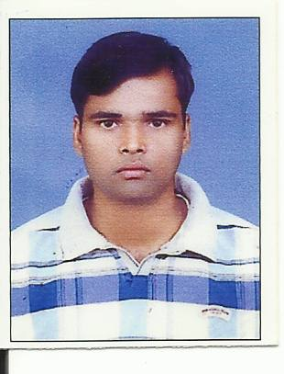

DHARMENDRA KUMAR SINGH

Mobile: 07383326769

Email: dharmendra.25jan@gmail.com

|  |
| --- |
| Personal Data  *Father’s Name: Ram Suresh Singh*  *Sex : Male*  *Nationality : Indian* Marital Status: Married Permanent Address  *C/O:Mr. Ramesh Singh*  *Vill- Kandehra*  *P.O. - Pipara*  *Dist- Kaimur(`BIHAR)*  *Pin Code:821108*  *Ph. No.: 07383326769* |

Experience

Overall **six years six months** work experience as an e procurement and pfms government project with different module and mode of software application(training of software application. mis data analysis trouble shooting, monitoring, software implementation Controller General of Accounts (**CGA**) software implication adviser )

Company Name: e centric solution PVT .ltd. and the union international unions against tuberculosis and lung diseases.

URL: PFMS.NIC.IN/Eprocure.gov.in

**Designation:**  **Analyst and MIS SOFTWARE** **Programmer (with excel data specialist)**

**Duration: Software Implementation and MIS Data Analysist with Team Management (March 2011 to June 2017)**

1. Handle complex analysis requests from Department, conduct research and analysis and share results with relevant Department officials.

**II.** Oversee use of defined formats and templates for data analysis by own team to ensure, Consistency within own Department and across the organization.

1. Seek guidance and assistance of Nodal Data Analytics Centre for carrying out the monitoring analysis and reporting activities as required
2. Coordinate the preparation of customized and ad hoc MIS reports and packs (financial and nonfinancial, including program reporting) to ensure that senior officials in Department have the relevant information needed to track performance and support decision making.
3. Provide on-the-job training and constructive feedback to subordinates to support their overall development.

**Continuous Improvement**

• Identify opportunities for continuous improvement of systems, processes and practices taking into Account best practices, in order to facilitate cost optimization and productivity improvement.

• Participate in projects to enhance existing MIS reporting systems to ensure the organization’s MIS systems are trustworthy source of relevant and timely data.

**Technical Skill: - PFMS Software implementation and MIS data analyst programmer**

Modules developed by PFMS for stakeholders as per the Union Cabinet above mandate are as under:  
**I. Fund Flow Monitoring**  
        (a) Agency registration   
        (b) Expenditure management and fund utilization through

PFMS EAT (Expenditure-Advance-Transfer modules)   
        (c) Accounting Module for registered agencies   
        (d) Treasury Interface

(e) Fund tracking for State schemes   
**II. Direct Benefit Transfer DBT modules**  
        (a) PAO to beneficiaries (b) Agency to beneficiaries

(c) State treasuries to beneficiaries   
**III. Interfaces for Banking**  
        (a) CBS (b) India Post (c) RBI

(d) NABARD & Cooperative Banks

**Experience Skill:-**

1. Tracking of flow of funds to the lowest level of implementation.

2. On line information of bank balances to facilitate “just-in-time” provision of funds to implementing agencies.

3. E-Payment to ultimate beneficiaries.

4. Decision Support System for all levels of programme managers.

5. Dissemination of relevant information to citizens.

6. Enhance transparency and accountability in public expenditure.

Educational Profile

Degree : **Bachelor of Engineering and pursing MBA from rgtv university.**

**(Information Technology)**

Institution : Jawaharlal Institute of Technology Borawan

University : Rajiv Gandhi Proudyogiki Vishwavidyalaya Bhopal

% of mark : 70%

Course : **10+2 I SC (Math, Physics, chemistry)**

Board : BSEB Patna

% of Marks : 56.67%

Course : **10th (Matric)**

Board : BSEB Patna

% of Marks : 60%

**Declaration**

I hereby declare that all the above details are true and correct to the best of my knowledge. I bear the responsibility for the correctness of these particulars.

**Date:**

**Place: (Dharmendra Kumar Singh)**