Resume

|  |
| --- |
| **Sunil Kumar**  Mailing Address : E-98 , Sector-72,  NOIDA    Mobile : 09999101057  08077024919    E-mail : [Sunil470763@yahoo.co.in](mailto:Sunil470763@yahoo.co.in)  Sunil470763@gmail.com |

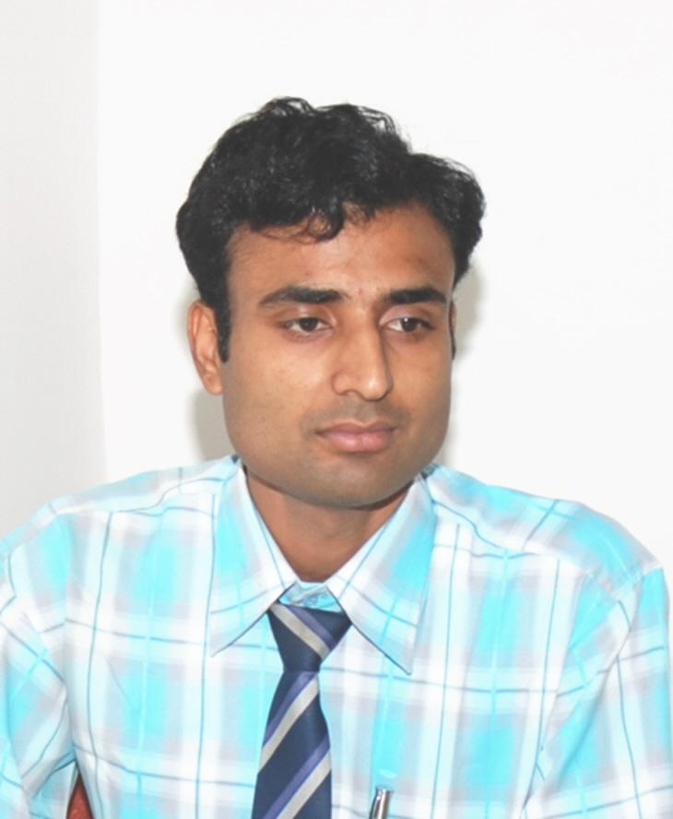

|  |
| --- |
| Career Objective |

To be a partner in the growth of an organization through the application of my skill and knowledge and to explore myself fully to contribute the organizational goals and objectives.

|  |
| --- |
| Educational Qualifications |

**MCSE Microsoft Certificate Pass 2009**

**(Microsoft Certified System Engineer)**

**B.Tech.** **S. D. College of Engg. & Tech.**  **Ist 2004**

**Computer Science** **& Engineering MZN(U.P.)**

**(U. P. Technical Univ., Lucknow)**

**Intermediate U. P. Board Ist 1998**

**High school U. P. Board IInd 1996**

|  |
| --- |
| Project |

The project “**Airways Reservation**” in ‘visual basic’ and ‘M.S.Access’ as a backend under the guidance of Prof. Yogesh Sharma, Head, Deptt. of Computer Science, S. D. College of Engineering & Technology, Muzaffarnagar (U.P.)

Six weeks Practical Summer Training at “B. H. E. L. (Bharat Heavy Elecrical Ltd.) Haridwar”. During this training, I have developed C++ Program for library management.

|  |
| --- |
| Practical Experience |

1. Presently working since 1st Jan-2018 with **Dimension Data India Pvt Ltd** **as Network Engineer.**

Responsibilities: Managing Server 2003, (ADS, DHCP, DFS, Symantec EndPoint Protection), ISA SERVER-2004 & 2006 and ISA Policy implementation, Application Software’s, Hardware maintenance work and Wifi enabled Network Work. At Present Working on PNB project at the site of PNB HO Rajendra Place, New Delhi and handling one ISA SERVER-2004 , three MPLS lines, two network {one for internet (200 PC’s) with Proxy server and one for Finacal (600 PC’s)} and One Wifi network on this site and coordinating with third party vendors (Hitachi ,Insolution Global Ltd, TCS,Airtel, MTNL, Ultra Teltronics,etc ) to resolve the issues related to these networks.

**2**. **Eight Year and Nine Month** **working Experience** (23rd March-2009 to 31st Dec-2017) with **HCL COMNET LTD (NOIDA) as Sr. Analyst-Systems.**

Responsibilities: Managing Server 2003, (ADS, DHCP, DFS, Symantec EndPoint Protection), ISA SERVER-2004 and ISA Policy implementation, Application Software’s, Hardware maintenance work and Wifi enabled Network Work. At Present Working on PNB project at the site of PNB Atmaram House, New Delhi and handling one ISA SERVER-2004, three Lease lines, three ISDN Lines, two network {one for internet (200 PC) and one for Finacal (100 PC)} and Two Wifi network on this site and coordinating with third party vendors (Wipro, TCS, Antivirus support, Airtel, MTNL, Ultra Teltronics,etc ) to resolve the issues related to these networks.

**3. One Year and Ten Month working Experience** (21stMay-2007 to 20th March-2009) with **ICFAI Business School Noida (IBS-N) as Asst. System Administrator.**

Responsibilities: Managing Server 2003(DHCP,ADS,ISA) and Labs Software and Hardware maintenance. .Managing all lab resources. Installations of Software’s and Lab Networks {450 nodes (100 Desktop and 350 laptops)}. And all Wi-Fi enabled network work.

**4. Five Month working Experience** (18thDecember-2006 to 20thMay-2007) with **Cube software Pvt. Ltd**. **Noida** **as Technical support Engineer.**

Responsibilities: Resolving the problem related to the Call Billing Server, Voice Logger Server, Voice Mail Server and Interactive Voice Response Server online.

**5. One year and nine month** (10th March-2005 to 10th December-2006) **working Experience** with **Graphic Era** **Institute of Technology, Dehradun** **(An Engineering College Approved by AICTE, Min of HRD Govt. of India, Affiliated to HNB Garhwal University) as** Systems & Network Support Professional (Lab Coordinator).

Responsibilities: Taking scheduled lab batches of B.Tech and MCA. Labs Software and Hardware maintenance. .Managing all lab resources. Installations of Soft wares and Lab Networks (80 nodes). and server2003 in the lab.

**6. Nine month**(11th June-2004 to 5th March-2005) **working Experience** **as** Lab Incharge **with Uttranchal InfoTech Institute, Dehradun (affiliated by M.C.R.P. University Bhopal).**

Responsibilities: Conducting theory and lab batches as per the schedule, maintaining the Software, Hardware and lab Network.

|  |
| --- |
| Computer Awareness |

**Operating Systems**:

Installation, Management, Configuration and Troubleshooting of Windows Server-2003, 2008, & 2012, ISA Server-2004 & 2006, Windows XP, Windows Vista, Windows 7, Windows 8, Windows 10 and Linux.

**Application Software’s**:

Installation, Management, Configuration and Troubleshooting of M.S.Office all versions (Word, Excel, Power Point, Outlook, etc), Photoshop. Winrar, Winzip, JRE , Adobe Reader, Team Viewer , Nero, Roxio, Internet Explorer all versions, Opera, Mozilla Firefox, Google Chrome , Internet Download Manager (IDM), Image Burner , VNC, Putty, CC Cleaner, IP Messenger, Registry Cleaner, Software Remover and all drivers of Hardware Components.

**Antivirus Software’s:**

Installation, Management, Configuration and Troubleshooting of **Symantec Endpoint Protection Manager (Server), Symantec Endpoint Protection (Client), Avast Antivirus, Mcafee Antivirus, Kaspersky Antivirus** and etc.

**Netwoking Knowledge:**

* Knowledge of windows server 2003

Active directory service (ADS)

Domain name service (DNS)

Dynamic host configuration protocol (DHCP)

Knowledge of file server (DFS) And Troubleshooting.

* Installation and Maintenance of Hardware and Software.
* Network Installation and Management.
* Performance Tuning & Optimization.
* Troubleshooting – Hardware, Software and Window Based Networks.
* System and Network Security. System Policies, Users and Groups.

|  |
| --- |
| Proficiency |

* **Networking with Windows** - Installation, Troubleshooting and Management of Users, Workgroups and Resources, system policies, troubleshooting & security issues. Active Directory DNS etc.
* **Installation, Management & Troubleshooting, Print Servers, Switches, Routers.**
* **Routers & Switches:** Installation, configuration and implementation of routers and switches in the different type of scenarios.
* **Static & Dynamic routing management with Windows.**

Installation, Configuration & Administration of Network Services – **Active Directory,** DNS, DHCP, Terminal Services, **RIS** etc.

* Software, Hardware and Network Installation, Management and Troubleshooting, Error Detection and Control.
* Administration with MS-Office Complete: - Skilled hand in Spreadsheet Solutions, Word Processing, MultimediaPresentations ,Database Management and setting-up Outlook (E-mail Client) Configuration ,Backup and rules implementation in different type of scenarios.
* **Knowledge of ISA Server 2004** (Installation, configuration, implementation, different type of restriction, etc )
* **IIS server Basic** knowledge of IIS 6.0 server installation and configuration of website.

|  |
| --- |
| Extra-Curricular Activities |

Participated in One Month camp of Scout Guide in 1993-1994.

Merit scholarships at school and college level when gain 70% marks in PCM.

Good Teamwork skills.

Fluent in English and Hindi.

|  |
| --- |
| Personal Information |

Date of Birth : January 05, 1981

Nationality : Indian

Permanent Address : Sunil Kumar S/O Late Shri Karan Singh,

Village – Dhamat, P. O. – Purkazi, Distt – Muzaffarnagar (U.P.)

|  |
| --- |
| Declaration: |

I certify that the information given above is true to the best of my knowledge and belief.

.Date: Place: Sunil Kumar