**BIODATA**

PERSONAL INFORMATION

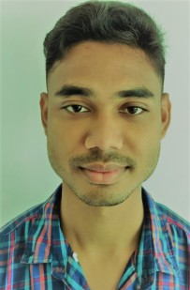

**NAME = YANKU DUWARAH**

**FATHER NAME = RAJEN DUWARAH**

**DATE OF BIRTH = 23-08-1996**

**SEX = Male**

**MARITAL STATUS = Unmarried**

**RELIGION = Hindu**

**CAST = OBC**

**LANGUAGES = English, Hindi, Assamese**

PERMANENT ADDRESS

**VILLAGE = 1 No. Boralimora**

**P.O = Bedeti**

**District = Biswanath (Assam)**

**STATE = Assam**

**P.S = Behali**

**PIN = 784179**

**CONTACT NO = 8073450322**

**EMAIL ID = yanku7775@gmail.com**

EDUCATIONAL QUALIFICATION

|  |  |  |  |  |
| --- | --- | --- | --- | --- |
| Exam | Year Passing | Name Of School/ College | Board/ University | Percentage |
| **H.S.L.C** | **2014** | **Pub Behali H.S School** | **SEBA** | **41%** |
| **H.S** | **2016** | **Pub Behali H.S School** | **AHSEC** | **53%** |

**COMPUTER SKILL.S = Computer Diploma 1 YEAR (ADCA)**

**WORK EXPERIENCE = RECEPTIONIST At Amazon Development Center pvt.ltd**

**2 Year 5 Month,**

**SALESMAN For Big Bazaar More Mega Store -2 year**

***Declaration***

***I hereby Declare That All The Above Information Are True To The***

***Best Of My Knowledge And Belief.***

**DATE =**

**PLACE = Signature of the Applicant**