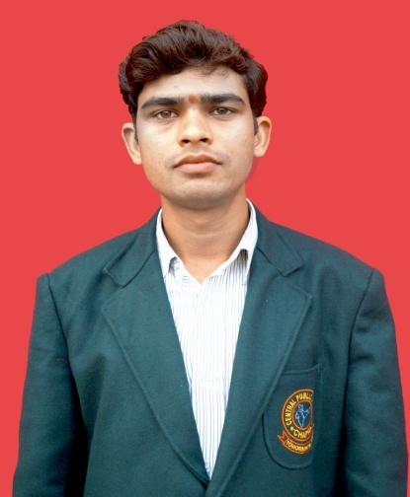**AMITESH KUMAR**

Vill-Panchpatra

P.O- Mukrera, P.S- Rivilganj

Dist- Saran Bihar (841213)

Ring Up: -+917277584957

+918804734542

E-mail:- [amiteshkumararyan@gmail.com](mailto:amiteshkumararyan@gmail.com)

*OBJECTIVE*

To work in a challenging environment where I am able to utilize my skill and also provide an opportunity to learn where in my qualification and qualities will be assets.

EDUCATIONAL QUALIFICATION

**●** Graduation Math’s (Hons.) from J.P University Chapra.

**●** Intermediate from B.S.E.B. Patna in 2012.

**●**Matriculation in 2010 FromBihar Board.

*PERSONAL CERTIFICATION*

# ●Advance Diploma in Computer Application (1 Year).

# ●Diploma in Hardware and Networking (1 Year).

WORK EXPERIENCE

**●**Hardware Solution and Via InfoTech in Chapra (13 Months).

**●**Currently work in Central Public School Chapra as a post of Hardware &

NetworkingEngineer.

TECHINICAL SKILL

**●**excellentinterpersonal, Organizational & Communicational skills.

**●**Responsible for overall implementation.

**●**Leadership

**●**Event Management. (Workshops, Trainings and coordination Meetings)

**●**Rapport building capacity.

**●**Computer Knowledge.

**●**Programme planning.

**●**Documentation.

**●**Reporting.

**●**Skill Related Environment.

**●**Installation, Formatting and Partition, of windows 98, XP, Windows 2000, Server

(2000, 2003, 2008), Linux, Vista, Windows 7, Windows 8, windows 8.1, Windows 10.

**●**Maintenance andInstallation of Printer, Fax & Scanner.

**●**Installation of Application Software.

**●** Backup/Restore File & Folder etc.

**●** Computer Repair.

**●**Internet Connection.

**●**DOS (Disk Operating System).

●SMPS (Switch Mode Power Supply).

**●**BIOS.

**●**Trouble Shootings.

**●**Networking & Sharing.

**●**Configure Wi-Fi.

**●**Repair Laser Printer HP 1005, 1136, 1020 & Cannon MF3010, 4750, BP2900 and all

Laser mini printers.

**●**Working knowledge about Ms-Office Package.

**●**Troubleshoot Smart class.

STRENGTH

Hardworking, Sincere, Self motivated & to work in organize manner.

INTERESTS

Net Surfing as well as Photography.

LANGUAGES

ENGLISH and HINDI

PERSONAL PROFILE

Father’s Name - Mr. Arvind Singh

Date of Birth - December 14th , 1994

Permanent Address - Vill :Panchpatra,P.O. :Mukrera

Dist :-Saran

Pin :- 841213 (Bihar)

Nationality - Indian

Sex - Male

Marital Status - Bachelor

**Declaration:**

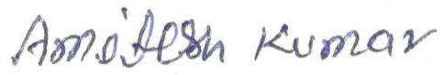**I hereby declare that the information furnished above is true to the best of my knowledge.**

DATE :20-05-2017

PALACE :Chapra