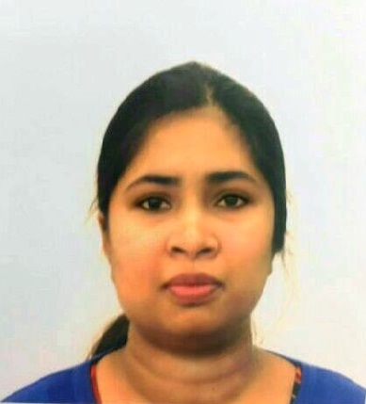**SUNITA KUMARI**

**Kolkata|| Phone: 7903667473||E-mail :** [**sunita3k9@gmail.com**](mailto:sunita3k9@gmail.com)

**EXPERIENCE SUMMARY**

Software professional with more than 9 year of experience in the area of Software

Developing and Programming in J2EE environment.

Currently associated with Tata Consultancy Services ltd (TCS).

Adept in end-to-end development of software products from requirement analysis to

System study, designing, coding, testing, de-bugging, documentation and implementation.

**EDUCATIONAL QUALIFICATION**

* MCA - 2012 from SASTRA University, Chennai with CGPA 6.2%.
* BCA - 2007 from Patna University with distinction aggregate of 82%.
* HSC - 2004 from Patna University with aggregate 60%.
* SSC - 2002 from Jharkhand State Board with aggregate 64%.

**TECHNICAL SKILLS**

* **Software and Language:** Java, SPRING, HIBERNATE, DB2, Basic AS400 commands, JSP, JSTL, Servlet, SQL, PL/SQL, HTML, UNIX.
* **Tools:** Eclipse, AS400 server, iSeries Navigator, WAS server, JIRA, BugZilla, Tortoise SVN, Toad, Putty, WinSCP.

**WORK EXPERIENCE**

**Since Nov, 2007 to present: Tata Consultancy Services** **Ltd**

**Project**: Insurance Project – Onsite (USA)

**Duration:** 12-Jul-2012 to 31-Oct-2016

**Project Details:** Worked as an Onsite Coordinator and lead in the Insurance based project which supports Company’s Agency Executives, Unit Manager and Agency Manager contracts and provides a multiple distribution administration and compensation functionality.

The scope of the project -

* To upgrade the old JAVA 1.3 Batch and SWING based UI applications to advance JAVA 1.6 SPRING Batch and Web Based UI application and
* To support the maintenance and system enhancement initiatives.

**Role and Responsibilities:**

* Enhancement and maintenance
* Coordination with the stakeholders to take their inputs for the proposed solution and implement the same.
* Requirement Analysis, preparation of Technical Specifications.
* Writing test cases and verification of test results.
* Guiding team members in terms of technically and domain specific knowledge.

Also, last three month worked as BA for the same project. Requirement gathering and preparing Business Requirement Documents were the main responsibilities.

**Technology:** Java, SPRING, HIBERNATE, JSP, JSTL, SWING, DB2, Basic AS400 commands

**Tools:** Eclipse, AS400 server, iSeries Navigator, WAS server, JIRA, BugZilla, Tortoise SVN

**Project**: Insurance Project – Offshore (Kolkata)

**Duration:** 12-Jul-2011 to 11-Jul-2014

**Project Details:** Worked as a developer in the same above mentioned offshore maintenance project. The scope of the project is to support the maintenance and system enhancement initiatives.

**Role and Responsibilities:**

* Requirement Analysis, preparation of Technical Specifications.
* Handling new enhancements and implementation.
* Testing and preparation of test documents. Writing test cases and verification of test results.
* Production Support.

**Technology:** Java, DB2, Basic AS400 commands

**Tools:** Eclipse, AS400 server, iSeries Navigator, BugZilla, Tortoise SVN

**Project**: Telecom project, Hyderabad

**Duration:** 01-May-2008 to 31-May-2011

**Project Details:** It is an electronic prepaid mobile phone recharge platform that enables a Telecom service provider to electronically distribute and sell innovative and flexible recharges to customers. It supports Flexi and Special recharges through various channels such as SMS, WEB portal and Payment Gateways.

**Role and Responsibilities:**

* Working as part of Production Support group.
* Providing solutions to the Business query and fixing the Production Bug.
* Enhancing existing system workflow
* Doing reconciliation activities. Involved in root cause analysis and clearing the discrepancy data in the reconciliation.
* Working on many UNIX reports and scripts and developed many scripts as per the user requirements.
* Working on many different projects’ Web and core applications to resolve production related issues.

**Technology:** Java, JSP, Servlet, SQL, PL/SQL, HTML, JSTL, UNIX.

**Tools:** Eclipse, Toad, Putty, WinSCP.

## ACADEMY PROJECTS

**Project**: Executive Promotion System at NTPC, Bihar.

**Description**: The objective of the system is to automate the promotion system of the company’s executives.

**Technology**: Visual Basic

## PERSONAL DETAILS

|  |  |
| --- | --- |
| **Name** : Sunita Kumari  **Date of Birth:** 1st Sep 1985 |  |