**KUMAR HARSH**

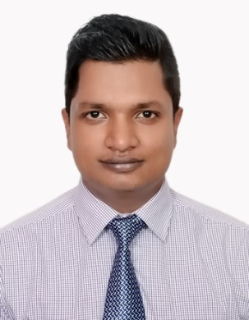**Email Id :** [**kumarharsh2203@gmail.com**](mailto:kumarharsh2203@gmail.com)

**Mobile no :- +918826486273**

**OBJECTIVES**

**Dynamic Marketing Professional with MBA-Marketing-Seeking an entry level opportunity with the marketing and communication department of an established organization .**

**To contribute to the success and expansion of an organization and at the same time grow both personally and professionally by continuously increasing my skills .**

**ACADEMICS**

* **Pursuing MBA Marketing from ITS ENGINEERING COLLEGE,GREATER NOIDA (2014-2016)**
* **B.TECH (Electronics & Communication) , MBU 2013**
* **Higher secondary :- B.S.E.B (Patna) 2007**
* **Matriculation :- B.S.E.B (Patna) 2005**

**SKILLS**

* **Operating system :- Windows 2000 , Windows 2003 , Vista , Windows 7 , Windows 8**
* **MS-office , MS-word , MS-Excel**
* **Strategy Planning**
* **People Management**

**PROJECT UNDERTAKEN**

* **TITTLE – Research of company (Brandwheel)**
* **COMPANY – knowledgExcel Services , C-192 ,Vivek Vihar Delhi – 110095 INDIA**
* **Duration – June 2015 to July 2015**

**ACHIEVEMENTS**

* **Third position in Inter college debate competition**
* **Hosted NATIONAL SEMINAR ON “ INNOVATIVE MANAGEMENT PRACTISES FOR CORPORATE SUCCESS”**
* **Organised CHILDRENS DAY for MBA department , ITS ENGINEERING COLLEGE , GREATER NOIDA**
* **Organised ALUMINI FESTIVAL for MBA department , ITS ENGINEERING COLLEGE , GREATER NOIDA**
* **Organised FAREWELL for SENIOURS for MBA department , ITS ENGINEERING COLLEGE , GREATER NOIDA**
* **Organised ORIENTATION PROGRAMME for JUNIOURS for MBA department , ITS ENGINEERING COLLEGE , GREATER NOIDA**
* **Participants in DEBATE COMPETITION on occasion of ‘NATIONAL UNITY DAY’**

**PERSONALITY TRAITS**

* **Versatile Personality**
* **Strong Interpersonal Skills and analytical skills**
* **Strong leadership and motivational skills**
* **A good team player with an ability to grass new things quickly . Strong analytical, Problem solving , organizational ability**
* **Willing to learn**
* **Team facilitator**
* **Good in building & maintaining relationship**
* **Strong Counselling & Convincing Techniques**
* **Positive Attitude**
* **Proven ability to work well in a fast paced environment**
* **Able to take initiative and work independent**
* **Excellent organizational skills**
* **Detailed orientated**
* **Ability to multitask and prioritize work**
* **Strong interpersonal and communication skills**

**Extra Curricular Activities**

* **Participated in College Cricket Tournament**
* **Participated in College festival**

**Area of interest**

* **Listening to music**
* **Interacting new people**
* **Travelling**

**PERSONAL DATA**

* **Date of birth – 13th august 1990**
* **Marital Status – Unmarried**
* **Sex – MALE**
* **Language – Hindi , English**
* **Religion - Hindu**
* **Address- 303,gautam nagar , NEW DELHI -110049 , INDIA**