**RESUME**

**Mukesh Kumar Sharma**

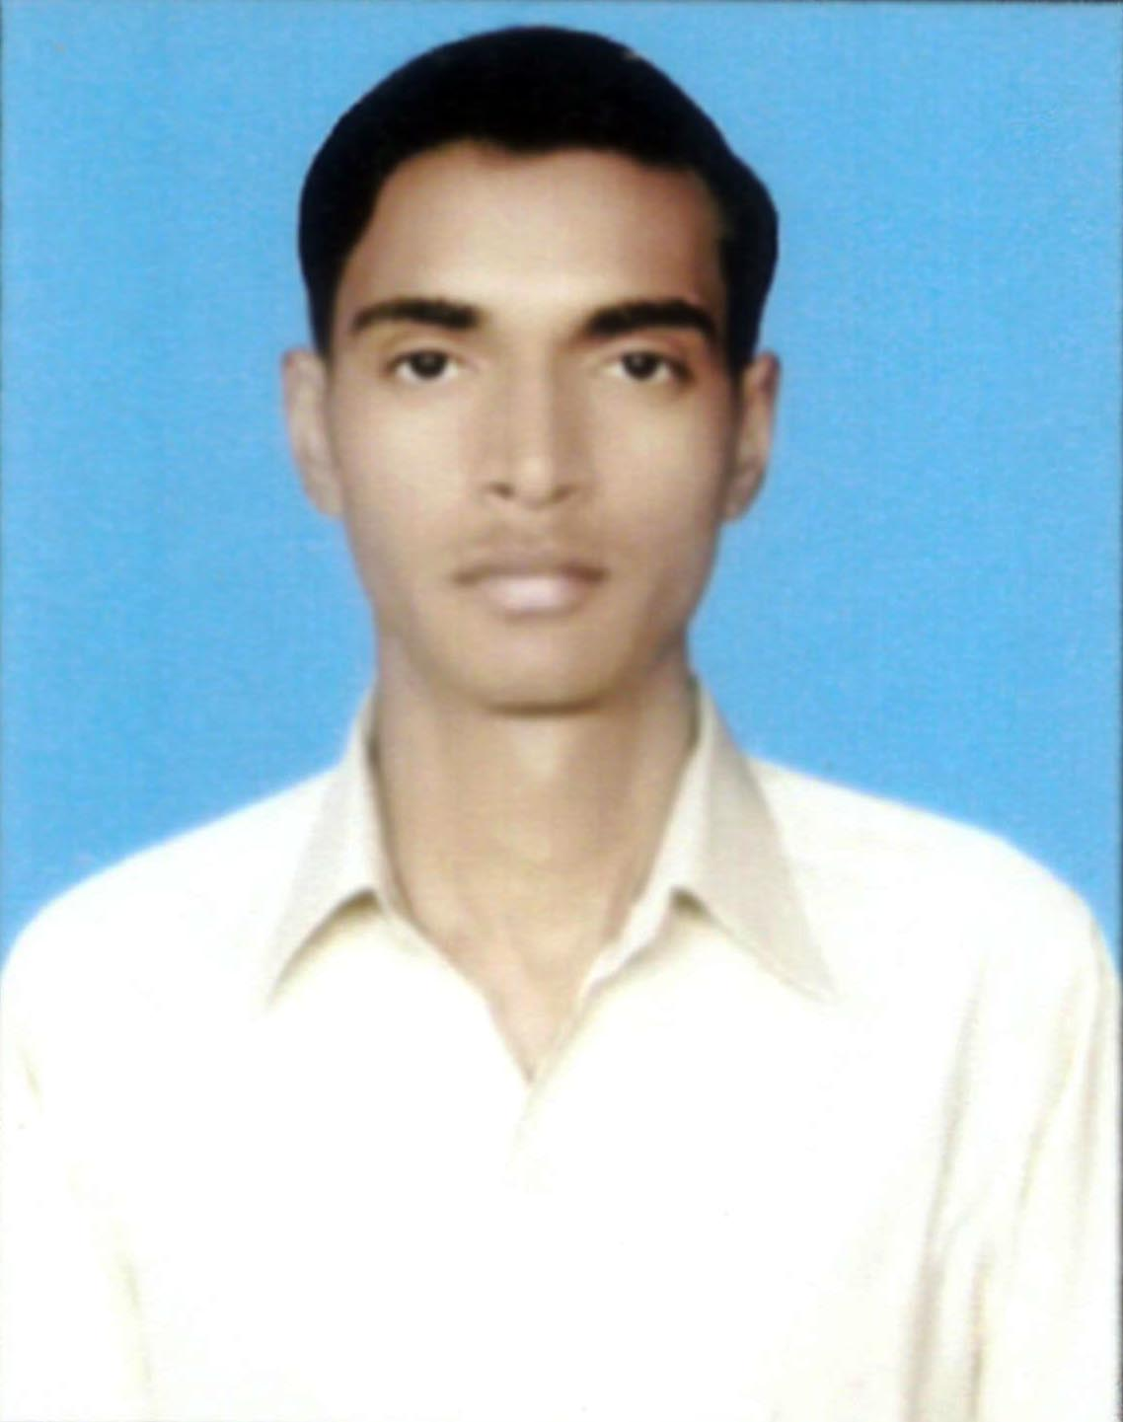

**At- Kalipur, P.o- Pochari**

**Dist- Dhanbad ( Jharkhand)**

**Pin:- 828306**

**Mob:- +91 9546812472**

**+91 8051012344**

**E-mail:-**[**kumarsharmamukesh98@gmail.com**](mailto:kumarsharmamukesh98@gmail.com)

**CAREER OBJECTIVE:-**

To excel in my field through hard work, skills and perseverance. To serve my parents, and my country with the best of my abilities**.**

**ACADEMIC QUALIFICATIONS:-**

|  |  |  |  |  |
| --- | --- | --- | --- | --- |
| **Course** | **Board** | **School/College** | **Year of Passing** | **Aggregate** |
| Diploma in  Computer Engg. | State Board of Technical Education, Jharkhand | Government Polytechnic ,Bhaga ,Dhanbad | 2014 | 75% |
| Higher Secondary( I.Sc) | Central Board of Secondary Education, Delhi | Saraswati Shishu Mandir ,Shayamdih | 2009 | 63.4% |
| Matriculation | Central Board of Secondary Education, Delhi | D. A.V Public School, Barora, dhanbad | 2007 | 68.4% |

**COMPUTER SKILLS:-**

* Operating System :- Windows (XP/7/8)
* Application Software :-Ms Office , Photoshop .etc
* Web Technology :- HTML

**AREA OF INTEREST :-**

* Electronics
* Networking
* Hardware

**ADDITIONAL QUALIFICATIONS :-**  CCNA (basic knowledge)

HARDWARE & NETWORKING

**STRENGTHS:-**

* Quick Learning Capability
* Hard Working Nature

**LANGUANE KNOWN:-**

* Hindi & English

**EXPERIEANCE:-**

* Eight months workingExperience inCISCO Router installation and Integration in Reliance Jio (4 G) in INDS Company .

Two Years working Experience in CISCO Router installation and Integration in Reliance Jio (4 G) As well As Hardware & Networking (SBI Bank setup) in HCL Infosystem Ltd.

**PERSONAL INFORMATION:-**

* Name :Mukesh Kumar Sharma
* Father’s Name :Mr. Bhagat Barhi
* Mother’s Name : Smt. China Devi
* Date of Birth :28thFeb1992
* Blood Group : O +ve
* Sex : Male
* Marital Status : Unmarried
* Nationality: Indian

**DECLERATION:-**

I hereby declare that the above mentioned information is correct up to my knowledge and I bear the responsibility for the correctness of the above mentioned particulars.

**Date:**-

**Place**: -Dhanbad **Signature**

(Mukesh kumar Sharma)