**RESUME**

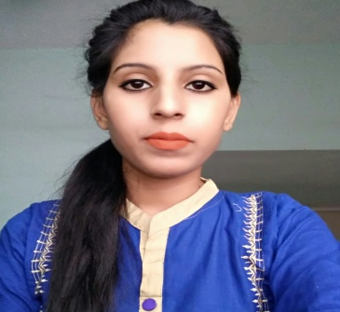

**NISHA KUMARI** *✆*Mobile:- 8789445707

Gamharia, SeraikelaKharsawan 🖂E-mail:-nishaku777@gmail.com

Jharkhand

**CARRIER OBJECTIVE:**

To grow with the company where I can effectively contribute my software skills as professional.

**ACADEMIC**

* **B.C.A (Bachelor of Computer Application)** from XITE, GAMHARIA, JAMSHEDPUR **.Jharkhand (State Board) in session of 2013-2016 .**.
* **Class 12th**( B.Sc) from Jamshedpur Women’s college, Jamshedpur, Jharkhand (**State Board**) in session of 2011-2013.
* **Class 10th** from Vidya Bharti high school Jamshedpur, Jharkhand (**State Board**) in 2011.

**ACADEMIC PROJECT**

* **PROJECT 1 : ONLINE SCHOOL MANAGEMENT SYSTEM :**Computerizing the functions in the school like creating database, billing, human resource details, expenses, inventory, etc. to make the process easy.
* **Front end :** PHP
* **Backend :** Microsoft SQL

**INTERNSHIP**

* Undergoneone month training in **IDTR, Jamshedpur.** (For hardware and networking course).
* Undergone one month training in **ASL ENTERPRISES LTD., JAMSHEDPUR** for Data operated.

**COMPUTER PROFICIENCY**

* **Programming Languages:** Java, PHP,CSS, C, C++
* **Operating Systems:** Windows , Linux, MS-DOS
* **Web designing Languages:** HTML
* **MS office (Word, Excel & Power Point)**

**EXPERIENCE**

**Total Experience : 1.5 years**

Currently Working with **ASL ENTERPRISES LTD.**A part of ASL Group (SeraikelaKherswan).

* Data operating in master sheet.
* All type of mail communication.
* Rate Quote of material & product as per market value and stock ability.

**Hobbies**

* Web development
* Internet Surfing
* Listening songs

**PERSONAL DETAILS**

|  |  |  |
| --- | --- | --- |
| **Name** | : | Nisha Kumari |
| **Date of Birth** | : | 07-09-1996 |
| **Gender** | : | Female |
| **Nationality** | : | Indian |
| **Languages** | : | English, Hindi. |
| **Permanent Address** | : | Gamharia Seraikela Kharswan,State:- Jharkhand-832108 |
| **Present Address** | : | GamhariaSeraikelaKharswan,State:- Jharkhand-832108 |
| **Email** | : | nishaku777@gmail.com |
| **Mobile** | : | 8864059019 & 8789445707 |

**Place: JHARKHAND**

**Date: 06.04.2017 NISHA KUMARI**