**RESUME** 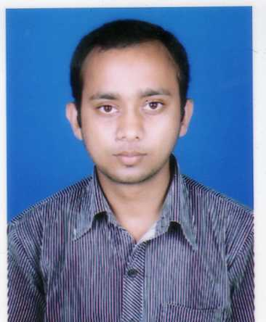

**Rishabh Sinha**  E mail: rishabhsinha20@yahoo.com

“Sinha Sadan” Mob:+91-9931699467

Pathri Ghat,

Tripolia Gate,

Patna- 800007.

**Objective:**

Intend to build a career in a hi*-*tech environment with proficient people who will help me to explore my skills and to realize my potential. Also willing to work as a key person in challenging and creating environment which will help me groom with competent qualities.

**Education:**

|  |  |  |  |  |
| --- | --- | --- | --- | --- |
| **Name Of Exam** | **Institution** | **Board/ University** | **Year Of Exam** | **Percent** |
| **B.com (Accounts Hons)** | D.D.E. | Patna University | 2009-2012 | 56.75% |
| **Class 12th** | Oriental CollegePatna. | Bihar School Examination Board | 2007-09 | 61.6% |

**Work Experience:**

**Working as Officer-Admin & Infra, Chola Mandlam MS general Insurance Company limited., (Murugappa Group), handling Bihar & Jharkhand Branches (payroll of Addeco India Pvt Ltd.)**

Worked as **Sr. Accounts Cum Marketing Executive** at **Aakash Institute**, Patna Branch.

Date of Joining 5th Sept 2012.

Job profile:-

1. Maintaining Daily collection report (DCR) of Cash Counter, Petty Cash & Utility.
2. Making salary of D grade staffs on the monthly basis.
3. Maintenance of Attendance of Admin Staffs & Utility Staffs too.
4. Control official Banking activity.
5. Coordinating in receiving Bills form different monthly and occasional vendors and make sure of its payment and take care of their T.D.S deduction (If needed).
6. Making terms with Principles of different schools for marketing point of view.
7. Managing & motivating counsellors.
8. Taking care of P.D.C received.

# Extra Qualification

|  |  |
| --- | --- |
| 2011 | Certificate of Completion from **MICROSOFT**, in it’s Digital Literacy Certificate Test. |
| 2010 | Done CERTIFIECATION in **FINANCIAL EXECUTIVE** Course from  **INSTITUTE OF COMPUTER & FINANCE EXECUTIVES**,  This Course is designed by **IIM Lucknow**.  Got **Grade “A” (82%)** in that. |
| 2009 | Participated in **NATIONAL ACCOUNTING TALENT SEARCH 2009-10**  (National Wide Accounting Knowledge competition)  Organised by **INDIAN ACCOUNTING ASSOCIATION.** |
| 2002 | **Search Foundation** got Certificate of Appreciation. |

**Languages:** English & Hindi.

**Key Skills:**

Operating Systems: Windows 98/XP/Vista

Programming: DOS.

Applications: L.M.S. & E.R.P., C.M.S., F.M.S., M.S.Office 2007, Tally 9 ERP.

**Personal:**

Date of Birth: (dd/mm/yy): 10/04/1990

Marital status: Unmarried

Nationality: Indian

Hobbies: Reading Story books, Playing Badminton.

Strength: - Honesty and creative thinking, which helps in business development & in running too.

Weakness: - Time management.

Mother’s Name: Mrs Sangeeta Sinha.

Mother’s Occupation: Housewife.

Father’s Name: Mr. Kushendra Kumar Sinha.

Father’s Occupation: - Regional Manager, Pooja MACHIANS [INDIA] LTD.